QuickDine: A Digital Food Ordering and Queue Management System for University Canteens

A RESEARCH PROJECT

Data Structures and Algorithms

Submitted to:

Mr. Maxil S. Urocay, MSCS candidate

And to the Faculty of the

College of Information Technology

University of Negros Occidental – Recoletos, Inc

In Partial Fulfillment
Of the Requirements for the Course

CIT10333P

Submitted By:
Mhaifer Faith F. Alvarez
Dondon B. Sarad
James Chafferson T. Enoc

GROUP NAMES
MaxSarap x DragonSlayer

October, 2026

Table of Contents

TITLE PAGE 1
TABLE OF CONTENTS 2
BACKGROUND OF THE STUDY 3
STATEMENT OF THE PROBLEM 4
PROJECT OBJECTIVES 5
SCOPE AND LIMITATION 7
Scope 7
Limitations 8
SIGNIFICANCE OF THE STUDY 9
DEGREE-PROGRAM RELEVANCE 10
SUSTAINABLE DEVELOPMENT GOALS 11
DEFINITION OF TECHNICAL TERMS 12
REFERENCES 14

Chapter 1
Background of the Study
University canteens serve students, faculty members, and university staff who purchase food during breaks and lunch periods. Because many customers arrive within the same limited period, long lines and delays in service frequently occur. Kambli et al. (2020) found that capacity and queue-management decisions can affect the performance of campus dining operations. Similarly, Usluer, (2025) found that campus dining services may experience queue problems when customer demand exceeds the available service capacity. The current manual process requires customers to wait in line, state their orders to the canteen staff, and wait while the orders are recorded and prepared. Canteen personnel must receive orders, record the requested food items, arrange the order sequence, and prepare meals at the same time. Bari et al. (2025) noted that college canteens often face long lines, slow service, and crowded spaces during peak hours.
This problem affects students because their break periods are limited. Long waiting times may reduce the time available for eating, resting, studying, or preparing for the next class. Faculty members and university staff may also experience delays when they need to purchase food within a limited schedule. Canteen personnel are affected because they must manage multiple orders while continuing their food preparation and serving duties. Ardani and Aji (2024) reported that overcrowding during peak hours can lead to long queues and potential errors in order processing.
A Java-based application may help improve this situation by providing a system for recording and managing food orders. Through the proposed system, users may select available food items, enter the required customer information such as student/faculty ID, and submit their orders through a graphical user interface. The application may generate a unique Order ID that can be used to identify and retrieve a specific order. Canteen staff may view incoming orders, manage the order queue, update the order status such as preparing, serving, and ready for pickup, and confirm orders that are ready for pickup.
Data structures and algorithms are needed so the system can store, organize, process, and retrieve order records. A singly linked queue keeps orders in first-in, first-out sequence, so the order submitted first is processed first. Bari et al. ( 2025) explained that an order token can track a customer’s position in a queue and ensure that orders are processed in sequence. An ArrayList stores the order records, since their number grows and shrinks during system operation. A hash table links each unique Order ID to its order record, so entering an Order ID quickly retrieves the order and its current status. Algorithms govern how orders are added, removed, stored, and retrieved. Queue operations manage the sequence, ArrayList operations manage the records, and hash table operations connect Order IDs to their orders.
To address these difficulties, this study proposes QuickDine: A Digital Food Ordering and Queue Management System for University Canteens. The system will use a singly linked queue to organize food orders, an ArrayList to manage order records, and a Hash Table to retrieve orders through their Order IDs. Through these features, the proposed system aims to make the ordering process more organized and support customers and canteen personnel in managing food transactions.

Statement of the Problem
University canteens experience long queues and delays in food service during breaks and lunch periods because many students, faculty members, and staff purchase food within the same limited time. In a manual ordering process, canteen personnel must receive orders, record food items, arrange the order sequence, prepare meals, and answer customer questions at the same time. This may cause delayed service, misplaced order information, and confusion in identifying which orders should be processed first. The proposed QuickDine: A Digital Food Ordering and Queue Management System for University Canteens aims to address this concern by providing a computerized process for submitting, organizing, and retrieving food orders.
This study seeks to answer the following specific questions:
- How can QuickDine help students, faculty members, and university staff submit food orders and monitor their order information without relying entirely on manual ordering?
- How can the proposed application allow canteen staff to view incoming orders, manage the order queue, update order statuses, and identify orders that are ready for pickup?
- How can a singly linked queue be used to organize food orders in a first-in, first-out sequence so that orders submitted earlier are processed before later orders?
- How can an ArrayList be used to store and manage order records as the number of orders increases or decreases during system operation?
- How can a Hash Table be used to retrieve a specific order and its information using a unique Order ID?
- How can the system correctly process valid order inputs, reject invalid or incomplete information, and ensure that order records are properly added, updated, and retrieved?
- How can the application perform its required functions within an acceptable response time during the processing of multiple orders?
- How can the proposed system contribute to the achievement of Sustainable Development Goal 8: Decent Work and Economic Growth by helping canteen staff manage orders more efficiently and reduce manual work?
Project Objectives
The main objective of this project is to design, develop, implement, test, and evaluate QuickDine: A Digital Food Ordering and Queue Management System for University Canteens, a Java-based application that organizes food orders, manages the order queue, and retrieves order records using a unique Order ID.
1.To analyze the current manual food-ordering and queue-management process in the university canteen and identify the functions needed by students, faculty members, university staff, and canteen personnel.
2. To design a Java-based graphical user interface that allows users to select food items, enter required customer information, submit food orders, and receive a unique Order ID.
3. To develop a singly linked queue that organizes submitted food orders in a first-in, first-out sequence, ensuring that earlier orders are processed before later orders.
4. To develop an ArrayList that stores and manages order records as the number of orders increases or decreases during system operation.
5. To develop a Hash Table that associates each unique Order ID with its corresponding order information and retrieves a specific order using the Order ID.
6. To develop order-management functions that allow canteen personnel to view incoming orders, manage the order queue, update order statuses, and identify orders that are ready for pickup.
7. To implement input validation and error handling that accepts valid order information and rejects incomplete or invalid inputs.
8. To test the functionality, correctness, reliability, usability, and response time of the queue management, order storage, order retrieval, and order-status modules using structured test cases.
9. To evaluate the potential contribution of the proposed system to Sustainable Development Goal 8: Decent Work and Economic Growth by determining whether it helps canteen personnel manage orders more efficiently and reduces manual work.
Scope and Limitations
Scope
The project covers the design, development, and implementation of QuickDine, a mobile food ordering and queue management application for a university canteen. The application aims to help students place food orders and monitor their order status while allowing canteen staff to organize incoming orders and manage the serving process. Its scope focuses on food ordering, FIFO queue management, order tracking, user authentication, data storage, input validation, and the application of data structures and algorithms.
The primary users of QuickDine are students and canteen staff. Students will use the Customer Interface to select food items, submit orders, and check their order status. Canteen staff will use the Staff Panel to view incoming orders, serve the next pending order, update order statuses, cancel pending orders, and clear finished records. The two interfaces will have different access permissions to prevent customers from accessing staff-only functions.
QuickDine will include a login system for authorized staff. Staff members must enter their login credentials before accessing the Staff Panel and its order management functions. Customers will have access only to customer-related features, such as placing food orders and tracking their orders. This separation will help protect order management functions from unauthorized access.
The application will be designed specifically for compatible mobile devices. Students and canteen staff will access QuickDine through the mobile application installed on their supported devices. The system will not provide a desktop or browser-based interface. A network connection will be required to submit orders and share updated order information between customers and canteen staff.
The project will implement a custom queue using a singly linked list to manage pending food orders. Each successfully submitted order will be added to the rear of the queue. When staff select the Serve Next Order function, the earliest pending order will be processed first and moved to the Preparing status. This follows the First-In, First-Out (FIFO) principle, which means that the first order placed will be the first order processed. The queue will support adding orders at the rear and removing orders from the front in O(1) time. Staff will also be able to cancel orders that are still pending.
QuickDine will include an order tracking feature that allows customers to enter their Order ID and check the current status of their orders. The system will display whether an order is Pending, Preparing, Ready for Pickup, Claimed, or Cancelled. For orders that are still pending, the system will also show their position in the queue. This feature will help customers monitor their orders without repeatedly asking canteen staff for updates.
The Staff Panel will provide canteen staff with an organized view of incoming orders and their details. After logging in, authorized staff can serve the next pending order, update order statuses, cancel pending orders, and clear finished records. The panel will also display counters for Pending, Preparing, Ready for Pickup, Claimed, and Cancelled orders. These functions will help staff monitor current orders and organize the food preparation and pickup process.
The system will use a custom resizable array list to manage menu items, cart items, items belonging to each order, and active order records. The array list will begin with a capacity of four elements and double its capacity when it becomes full. This will allow QuickDine to handle a changing number of items and order records without depending on a fixed array size.
A custom hash table using separate chaining will be implemented to associate each unique Order ID with its corresponding order record. When a customer or staff member searches for an Order ID, the hash table will help retrieve the correct order and its current status. The hash table will perform rehashing when an insertion would cause the load factor to exceed 0.75. Under suitable conditions, searching for an order is expected to take O(1) time on average.
Input validation will be included to help prevent incorrect or incomplete information from being processed. The system will check login credentials, Student IDs, Order IDs, food quantities, and required order details before processing requests. Invalid entries will be rejected, and appropriate messages will be displayed. The system will also check staff authorization before allowing access to staff-only functions. The service layer will validate information before modifying the data structures to help maintain accurate and consistent records.
QuickDine will handle the information necessary for food ordering and order tracking, including staff login information, Student IDs, food items, quantities, prices, order totals, Order IDs, order statuses, and order placement times. Only information necessary for the system’s intended functions will be collected. Student IDs will be stored as text to preserve leading zeros.
Limitations of the Project
The project is specifically designed for food ordering and queue management within a university canteen. It focuses on placing orders, organizing the serving sequence, tracking order statuses, and managing current order records. It is not intended to function as a complete canteen management system. Features such as inventory monitoring, supplier management, employee management, and detailed financial reporting are not included in the current version.
QuickDine will be developed for compatible mobile devices only. It will not provide a desktop version or a browser-based interface for computers and laptops. Users will need a supported mobile device to access the application. Its performance and appearance may vary depending on device specifications, operating systems, and application compatibility.
The system will require a working network connection and an available server to share order information between customers and canteen staff. If the network connection is interrupted or the server becomes unavailable, customers may be unable to submit orders or check their order statuses, while staff may be unable to manage incoming orders until access is restored.
QuickDine will store active order records in memory while the server application is running and will not provide permanent transaction history through a database in the current project scope. As a result, records may be lost when the server process is restarted. Staff may clear finished or cancelled records, but cleared records cannot be recovered through the application. The system will therefore be limited in its ability to retain order information for long-term reference.
The login system will restrict the Staff Panel to authorized staff members. Customers will not be allowed to access staff-only functions, such as managing orders, changing order statuses, cancelling pending orders, and clearing finished records. However, the effectiveness of this protection will depend on the proper implementation of authentication, authorization, and login credential security. The system will not connect to the university’s official employee records to verify staff employment.
Student ID validation will be limited to checking the required format and number of digits. QuickDine will not connect to the university’s official student records to confirm whether a Student ID belongs to an enrolled student. It will also not automatically verify the identity of the person collecting the food. Staff may need to check the customer’s identification when necessary.
The system will display the total cost of an order but will not process payments through banks, electronic wallets, or online payment gateways. Customers will pay at the canteen counter using the payment arrangements available at the time of purchase. The application will not automatically verify or record transactions from external payment services.
QuickDine will not send SMS messages, emails, or notifications through external communication platforms when an order is ready. Customers must open the mobile application and enter their Order IDs to check their latest order statuses. The system will not provide automatic updates through external communication services.
The queue will follow the First-In, First-Out principle for pending orders. Staff will process the earliest pending order first and cannot move a later pending order ahead of an earlier one through the normal serving function. This approach maintains an organized serving sequence, but it does not automatically account for differences in food preparation time, special requests, or customers who may require priority service.
Performance evaluation will be conducted using the mobile devices and testing environment available to the researchers. Results may vary on other devices because of differences in hardware, software, operating systems, and network conditions. The project will evaluate the correctness and technical performance of the selected data structures and system functions, but it will not automatically establish that QuickDine reduces actual waiting time, improves customer satisfaction, or decreases staff workload in the university canteen.
Finally, the development of QuickDine is limited by the requirements and time available for the Data Structures and Algorithms academic project. The researchers will prioritize features directly related to food ordering, FIFO queue processing, resizable array list operations, hash table-based order tracking, mobile access, separate customer and staff interfaces, login and access control, and software testing. Additional features may be considered for future development, but their effectiveness must be established through implementation and testing. These limitations keep QuickDine focused on its primary purpose of providing an organized mobile food ordering and queue management application for a university canteen.
Significance of the Study
The project, “QuickDine: A Mobile Food Ordering and Queue Management System,” is developed to provide a more organized way of placing food orders and managing the serving process in a university canteen. Through its food ordering, order tracking, and staff management features, the application aims to make ordering more convenient for students and teaching personnel and help canteen staff organize incoming orders. The project also demonstrates how data structures and algorithms can be applied to a practical situation within the university. The following groups may benefit from the development of QuickDine.
1. Students and Teaching Personnel
Students and teaching personnel are among the primary beneficiaries of QuickDine because they can use the mobile application to place food orders and monitor their order statuses. Instead of repeatedly asking canteen staff about their orders, users can enter their Order IDs through the Customer Interface to check whether their orders are Pending, Preparing, Ready for Pickup, Claimed, or Cancelled. The system will also display the queue position of pending orders, helping users understand their place in the serving sequence.
QuickDine will allow users to select food items, choose quantities, review their orders, and check the total amount before submitting them. Since the application is designed for compatible mobile devices, students and teaching personnel can access its features through their supported devices. This may make the ordering process more convenient and help them stay informed about their orders. However, the actual waiting time will still depend on the number of orders, food preparation time, and canteen operations.
2. Canteen Staff
Canteen staff are among the primary beneficiaries of QuickDine because they are responsible for preparing orders and managing the serving process. The Staff Panel will provide an organized view of incoming orders, their details, and their current statuses. Authorized staff members can log in to access the panel, serve the next pending order, update order statuses, cancel pending orders, and manage finished records.
The system will apply the First-In, First-Out (FIFO) principle through a custom singly linked list queue. This will help staff process pending orders according to their arrival sequence. The order counters will also help them monitor how many orders are Pending, Preparing, Ready for Pickup, Claimed, or Cancelled. By organizing these functions in one interface, QuickDine may help staff manage orders more systematically and reduce the need to manually track each order. However, the actual improvement in staff workload will depend on how the system is implemented and used in the canteen.
3. Canteen Management
Canteen management may benefit from QuickDine through its organized order records and order status monitoring features. The Staff Panel will provide counters and order details that can help authorized staff monitor the current serving process. These features may help management understand the flow of orders during canteen operations and identify areas where order handling can be improved.
The system may also support more consistent order processing by applying FIFO queue management and providing a clear way to update order statuses. However, QuickDine is not a complete canteen management system. It does not include inventory monitoring, supplier management, employee management, or detailed financial reporting. Its benefits to canteen management are therefore limited to food ordering, queue organization, and order tracking.
4. The Researchers
The researchers will benefit from this project by applying the concepts learned in the Data Structures and Algorithms course to the development of a practical mobile application. Through QuickDine, they will gain experience in designing and implementing a food ordering system using Java and custom data structures.
The project will allow the researchers to apply a singly linked list for FIFO queue processing, a resizable array list for managing menu items and order records, and a hash table with separate chaining for Order ID lookup. They will also gain experience in implementing input validation, staff authentication, separate customer and staff interfaces, and software testing. Through functional and performance testing, the researchers can examine whether the selected data structures work correctly and observe how their performance changes as the amount of data increases. This experience may strengthen their programming, problem-solving, debugging, and system development skills.
Degree-Program Relevance
This project is related to the Bachelor of Science in Information Technology program because it develops a practical service system for the university canteen. The problem is an information-handling problem in a service process: orders must be recorded, sequenced, and tracked. The users are customers and staff of a small food-service operation who need an easy-to-use tool rather than a complex platform. The functions, such as order entry, status tracking, and staff order management, are typical of business applications that Information Technology graduates build and maintain. The technical solution applies graphical user interface design, input validation, data structures, and software testing, which are the core functions of the program.

Sustainable Development Goal Alignment
Selected goal
The project supports Sustainable Development Goal 8: Promote sustained, inclusive and sustainable economic growth, full and productive employment and decent work for all (United Nations, n.d.). The goal addresses productive work and the growth of enterprises, including Target 8.2, which calls for higher economic productivity through technological upgrading and innovation, and Target 8.3, which encourages the growth of micro-, small-, and medium-sized enterprises.
Connection to the project problem
A university canteen is a small food-service business. When orders are handled manually, the staff spend time and effort remembering the sequence of orders and answering status questions instead of preparing food. This lowers the productivity of the workers and the quality of service. Kim et al. (2020) showed that small restaurants with queues need deliberate strategies during peak periods to remain profitable.
Expected contribution
QuickDine is a simple technological upgrade of the ordering process. It records every order, enforces first-in, first-out service, and shows each order's status on screen. These functions may reduce repetitive manual work and order mix-ups so that staff can focus on preparing and serving food, which relates to Target 8.2.
Expected beneficiaries
The canteen staff benefit from a clearer workload, the canteen operator benefits from more orderly service during peak hours, and students benefit from fair and visible order handling.
Limitations of the contribution
The application supports only a small part of Goal 8. It does not create jobs, raise wages, or guarantee higher sales, and its effect on staff productivity has not been measured. The contribution is limited to supporting a more organized ordering process in one canteen.
Definition of Technical Terms
The following terms are defined according to how they are used in this project.
Active order
An order that is Pending, Preparing, or Ready for Pickup, or that has finished but has not yet been cleared from the Staff Panel list.
Capacity
The number of slots in the internal array of the CustomArrayList, including empty slots. It is different in size.
Cart
The temporary list of menu items and quantities chosen by a student before the order is placed. It is stored in a CustomArrayList.
Collision
The case in which two different Order IDs produce the same bucket index in the hash table. QuickDine resolves collisions by separate chaining.
CustomArrayList
The group's resizable array list class. It stores elements in an array and doubles the array when it becomes full.
Dequeue
The queue operation that removes and returns the order at the front of the queue. In QuickDine it happens when staff click Serve Next Order.
Enqueue
The queue operation that adds an order at the rear of the queue. In QuickDine it happens when a student places an order.
First-in, first-out (FIFO)
The rule that the order placed first is served first. The QuickDine queue follows this rule (Goodrich et al., 2014).
Front and rear
The two ends of the queue. The front holds the next order to serve; the rear holds the most recent order.
Generic type
A Java feature that lets a class such as LinkedQueue<E> work with any element type while the compiler checks that the correct type is used.
Graphical user interface (GUI)
The windows, buttons, tables, and text fields through which students and staff use QuickDine. It is built with Java Swing.
Hash function
The calculation that converts an Order ID into a bucket index: the Java hash code of the Order ID modulo the number of buckets.
Hash table
The group's HashTable class, which stores pairs of keys and values in buckets. QuickDine uses it to map each Order ID to its order.
Input validation
The checking of Student IDs, Order IDs, quantities, usernames, and passwords before they are accepted, both while typing and when the user submits.
Hash (password)
The 64-character text produced by passing a password through SHA-256 (NIST, 2015). QuickDine stores this hash instead of the password, so the password cannot be read from the database.
Java record
A short Java class form for carrying fixed data, such as MenuItem and OrderItem, whose fields cannot be changed after creation (Bierman, 2021).
Java Virtual Machine (JVM) heap
The memory area where Java objects, such as orders and nodes, are stored while the program runs (Lindholm et al., 2021).
Log-in
The process that checks a Student ID or staff username, the role, and the password before the screens of that role are shown. Everybody must log in before using QuickDine.
Load factor
The number of entries in the hash table divided by the number of buckets. QuickDine keeps it at or below 0.75.
Node
One element of a linked list, holding an order and a reference to the next node.
Order
A student's request for food, consisting of an Order ID, Student ID, list of order items, status, and time placed.
Order ID
The unique code given to every order, made of the letters QD, a hyphen, and a number that starts at 1001, for example QD-1001.
Order status
The stage of an order: Pending, Preparing, Ready for Pickup, Claimed, or Cancelled.
Queue
A linear data structure in which elements are added at the rear and removed from the front. QuickDine uses it for pending orders.
Queue position
The place of a pending order in the queue, counted from the front; position 1 is the next order to be served.
Registry
The CustomArrayList that holds all active orders in the sequence they were placed. The Staff Panel table displays it.
Rehashing
Creating a hash table with twice as many buckets and moving every entry to its new bucket when the load factor would go above 0.75.
Resizing
Creating a new array twice as large and copying the elements into it when the CustomArrayList is full.
Separate chaining
A collision-resolution method in which entries that fall into the same bucket are linked together in a chain (Knott & de la Torre, 1989).
Singly linked list
A sequence of nodes in which each node refers only to the next node. The QuickDine queue is built on a singly linked list.
Size
The number of elements actually stored in a data structure.
SQLite
A database engine that stores a whole database in one file and needs no server (SQLite). QuickDine uses it only for the accounts table.
Staff Panel
The screen, available only after a staff log-in, used by canteen staff to view the queue and active orders and to serve, update, cancel, and clear orders.
Student account
An account in the accounts table with the role STUDENT, whose username is the Student ID. Only staff can create it, on the Student Accounts screen; only a student with an account can place orders.
Student ID
The 6- to 12-digit number that identifies a student. The student uses it to log in, and every order the student places is saved under it. It is shown on the Staff Panel so staff can confirm who claims the order; it is stored as text so that leading zeros are kept.
Traversal
Visiting the nodes of the linked list one by one from the front, as done when finding the queue position of an order.

References:
Ardani, D., & Aji, A. S. (2024). Development of a web-based food and beverage ordering system for university canteens using the Laravel framework at University of Technology Yogyakarta. Journal of Scientific Research, Education, and Technology, 3(4), 1462–1474. https://doi.org/10.58526/jsret.v3i4.521
Bala Hariharan, G. D., & Poongodi, A. (2024). Canteen food ordering system and management. International Journal of Science, Engineering and Technology, 13(5). https://www.ijset.in/wp-content/uploads/IJSET_V13_issue5_581.pdf
El-Said, O. A., & Fathy, E. A. (2015). Assessing university students' satisfaction with on-campus cafeteria services. Tourism Management Perspectives, 16, 318–324. https://doi.org/10.1016/j.tmp.2015.09.006
Firmansyah, F., & Saputra, A. C. (2021). Effect of the implementation of queue system on customer satisfaction. Bongaya Journal for Research in Management, 4(1), 1–7. https://doi.org/10.37888/bjrm.v4i1.245
Gursale, T., Bhapkar, K., Rachha, A., Junghare, S., & Sonkar, S. (2026). QuickBite: Canteen ordering system. Journal of Advance and Future Research, 4(3), 974–977. https://rjwave.org/jaafr/papers/JAAFR2603982.pdf
Jiao, S., Wang, X., Song, D., & Du, S. (2022). Simulation and optimization of university canteen service under the situation of epidemic prevention and control based on queuing theory. ITM Web of Conferences, 47, Article 02052. https://doi.org/10.1051/itmconf/20224702052
Kambli, A., Sinha, A. A., & Srinivas, S. (2020). Improving campus dining operations using capacity and queue management: A simulation-based case study. International Journal of Information Management Data Insights, 1(1), Article 100007. https://doi.org/10.1016/j.jjimei.2020.100007
Ningman, Y., Wang, X., & Chen, X. (2023). Analysis on the service capacity of university canteens under the epidemic prevention based on queue theory. Transactions on Comparative Education, 5(7), 35–41. https://doi.org/10.23977/trance.2023.050706
Rambandara, R. D. S. S., Dilanthi, M. G. S., & Weerakoon, W. M. T. N. K. (2019). Simulation of the university canteen performance: A case study. University of Peradeniya. https://ir.lib.pdn.ac.lk/handle/20.500.14444/4087
Singh, J., & Singh, P. (2023). Application of queuing technique in an educational institute canteen. In Integration of AI-based manufacturing and industrial engineering systems with the Internet of Things. Taylor & Francis. https://doi.org/10.1201/9781003383505-16
Usluer, F. O. (2025). Solving queue problems in a campus dining service with discrete event simulation. Ege Academic Review, 25(2), 351–360. https://doi.org/10.21121/eab.20250207

RUBRIC A: PRELIM PROJECT OUTPUT (Working Prototype, Research
Paper, Hard Copy, and Soft Copy)
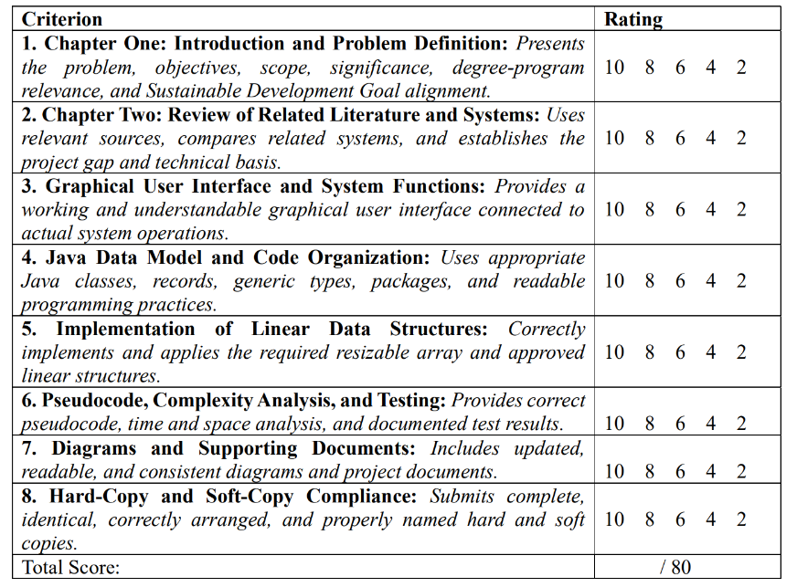

RUBRIC B: GROUP DEFENSE AND PRESENTATION
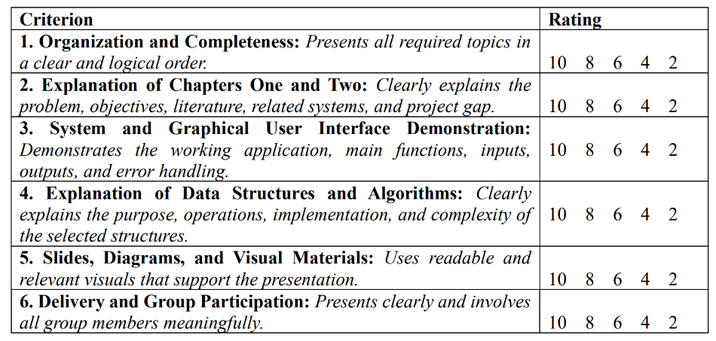

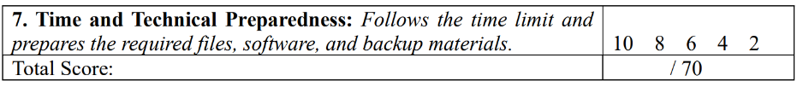

RUBRIC C: INDIVIDUAL QUESTION-AND-ANSWER PERFORMANCE

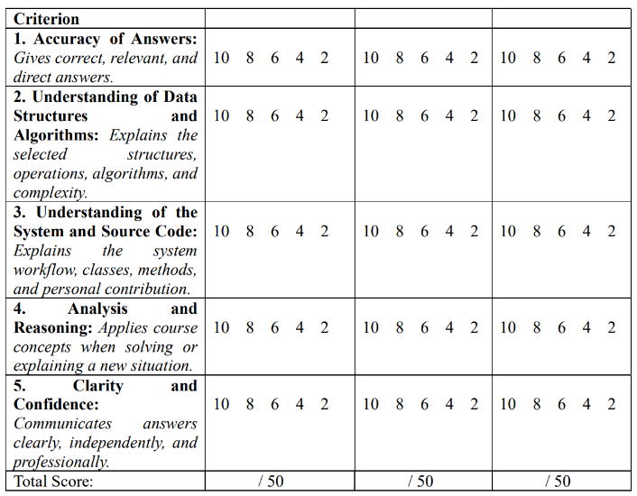
S

Chapter II
Related Literature
QuickDine is a Java-based Digital Food Ordering and Queue Management System for University Canteens. It focuses on receiving food orders from students, faculty members, and university staff, organizing submitted orders using a singly linked list queue, storing order records using an ArrayList, retrieving and updating orders using a hash table, and identifying orders that are ready for pickup. The literature related to QuickDine is organized around university canteen queuing problems, digital food ordering, queue management, order storage and retrieval, order status tracking, intended users and usability, and Sustainable Development Goal 8. The related systems are also reviewed to identify existing approaches to canteen ordering, queue tracking, and order management.

University Canteen Queuing Problems
University canteens serve students, faculty members, and university staff who purchase food during breaks and lunch periods. Because many customers arrive within the same limited period, long lines and delays in service frequently occur. Kambli et al. (2020) found that capacity and queue-management decisions can affect the performance of campus dining operations. Their study showed that assigning staff and service capacity properly can reduce customer waiting time.
Similarly, Usluer (2025) found that campus dining services may experience queue problems when customer demand exceeds the available service capacity. The study showed that long waiting times can lower customer satisfaction and that better use of staff and service stations can improve canteen service.
Bari et al. (2025) also noted that college canteens often experience long lines, slow service, and crowded spaces during peak hours. Their study explained that these problems become worse when customers order manually while canteen personnel receive orders, record food items, arrange the order sequence, and prepare meals at the same time.
These studies agree that canteen congestion is caused by high customer arrival, limited service capacity, and inconsistent preparation time. However, Kambli et al. (2020) and Usluer (2025) focus mainly on simulation and staffing decisions, while Bari et al. (2025) focuses on an online ordering system. QuickDine addresses this gap by using a singly linked list queue to preserve the sequence of incoming orders and provide staff with a clear active-order queue.

Digital Food Ordering and Order Tracking
Manual food ordering requires customers to wait in line, state their orders to canteen staff, and wait while the orders are recorded and prepared. This process may cause delays, repeated questions, and errors in recording or matching orders. Ardani and Aji (2024) reported that overcrowding during peak hours can lead to long queues and possible errors in order processing.
Ardani and Aji (2024) developed a web-based food and beverage ordering system for a university canteen. Their system allowed students, lecturers, and staff to choose food items, place orders, and pay online. This reduced the need for customers to stay in a physical line and helped canteen personnel receive organized order information.
Nwekori and Ignatius (2025) designed and implemented a web-based food-ordering platform for an academic environment. Their study found that digital order processing reduced processing time and minimized errors associated with handwritten or verbal orders. The system also received positive user feedback, showing that students and staff found it useful and easy to use.
Bari et al. (2025) developed an online food-ordering system for college canteens. Their system allowed users to place orders, receive an order token, and track their position in the queue. Testing showed that the system improved order accuracy, processing speed, and user experience.
Other digital canteen systems show similar benefits. Bhattarai et al. (2024) developed a QR-based canteen management system to improve canteen efficiency through digital technology. A 2024 IEEE study also proposed a mobile-based cashless canteen solution that uses QR technology and generates an Order ID for each transaction. The study stated that the system may reduce queue time and minimize mistakes during order processing. Abdul Rahman and Othman (2024) likewise developed a web-based food-ordering system for teachers to address manual ordering, limited menu options, and inefficient canteen processes.
These studies show that digital food ordering can reduce manual recording, speed up order processing, and give customers clearer information about their orders. Ardani and Aji (2024) focused on web-based ordering and payment, Nwekori and Ignatius (2025) focused on reducing processing time and errors, and Bari et al. (2025) focused on queue tracking through order tokens. Bhattarai et al. (2024), the 2024 IEEE study, and Abdul Rahman and Othman (2024) focused on QR-based, mobile, and web-based ordering systems. QuickDine follows these ideas but focuses on a Java-based stand-alone application that uses a singly linked list queue, an ArrayList, and a hash table.

Queue Management and FIFO Order Processing
A queue is useful for managing food orders because it follows the First-In, First-Out (FIFO) principle. This means that the order submitted first is processed first. Bari et al. (2025) explained that an order token can track a customer’s position in a queue and ensure that orders are processed in sequence.
Surbakti et al. (2024) developed an online canteen-ordering system that implemented the First Come, First Served algorithm. FCFS is similar to FIFO because the first order received is processed first. Their study reported that the FCFS algorithm was successfully implemented and that orders followed the expected sequence.
QuickDine uses a singly linked list queue to manage active orders. Each order is stored in a node, and each node is connected to the next order. When a customer submits an order, it is added at the rear of the queue. When staff begin preparing an order, the order at the front of the queue is processed first.
This structure works like an actual canteen line. It prevents later orders from being processed before earlier orders and helps staff see the current list of pending orders. Unlike Bari et al. (2025), who used a priority queue that considers factors such as preparation time and customer preference, QuickDine uses a simple FIFO queue to keep the processing sequence fair and easy to understand. It is similar to the FCFS approach of Surbakti et al. (2024), but QuickDine implements it using a singly linked list queue.
The studies by Kambli et al. (2020), Usluer (2025), Bari et al. (2025), and Surbakti et al. (2024) support the use of queue management because organized sequencing reduces confusion and helps staff handle many orders during busy periods. QuickDine applies this idea during order submission and preparation, not only after congestion has already happened.

Order Storage and Retrieval Using ArrayList and Hash Table
QuickDine uses an ArrayList to store submitted order records. An ArrayList is appropriate because the number of orders increases and decreases while the system is running. It allows the system to keep order information, display order history, and show summaries even after an order has been removed from the active queue.
The ArrayList is useful for staff because it can display all submitted orders and help generate reports or summaries based on order status. Since it keeps records in an ordered list, staff can easily view the orders stored in the system.
However, searching an ArrayList one record at a time can become slow when there are many orders. Because of this, QuickDine also uses a hash table to find a specific order using its unique Order ID. The hash table connects each Order ID to its order record, allowing the system to retrieve the order and its current status without checking every record.
The use of an Order ID is supported by the 2024 Cashless Canteen Mobility Solution, which also generates an Order ID for each transaction. However, that study focuses more on mobile ordering, QR technology, and delivery. QuickDine uses the Order ID with a hash table for direct retrieval and status updating.
The hash table is important for both customers and staff. When a student enters an Order ID, the system can find the matching order and show its status. When staff update an order to “Preparing,” “Serving,” or “Ready for Pickup,” the system can locate and update the same record through the hash table.
The ArrayList and hash table have different purposes. The ArrayList keeps a complete record of submitted orders, while the hash table allows fast retrieval using the Order ID. Together with the singly linked list queue, these structures separate active-order processing, order storage, and direct order retrieval.

Order Status Tracking and Smart Pickup
Order status tracking is important because students need to know whether their orders are still being prepared, being served, or already ready for pickup. Without status updates, customers may repeatedly ask canteen staff about their orders, which can add to the workload of personnel during busy periods.
Ardani and Aji (2024) showed that digital ordering systems can provide canteen personnel with organized order information. This supports QuickDine’s use of status labels such as “Pending,” “Preparing,” “Serving,” and “Ready for Pickup.”
Nwekori and Ignatius (2025) also found that digital food-ordering platforms improve order processing and reduce errors associated with manual ordering. This supports QuickDine’s use of a hash table to retrieve an order using its Order ID and update its status accurately.
Bari et al. (2025) used order tokens to help customers track their position in the queue. QuickDine is similar because it allows customers to check their order status using a unique Order ID. However, QuickDine also provides Smart Pickup Management, which identifies orders marked as “Ready for Pickup.” This helps staff see which completed orders still need to be claimed and prevents students from repeatedly asking if their food is ready.
Intended Users and Usability
The main users of QuickDine are students, faculty members, and university staff who order food, as well as canteen employees who receive and prepare orders. Students need a simple way to view food items, enter their ID, choose quantities, receive an Order ID, and check their order status. Canteen staff need a dashboard that shows incoming orders, preserves the order sequence, allows Order ID searching, and supports status updates.
Ardani and Aji (2024) emphasized that both customers and canteen owners should be considered when developing a campus ordering system. Their system separated customer ordering functions from canteen-management functions, which helped improve usability and user satisfaction.
Nwekori and Ignatius (2025) also found that usability testing showed positive user acceptance of a digital food-ordering platform. This supports QuickDine’s inclusion of input validation, clear status labels, pickup information, and error handling. A system may be technically efficient, but it will still be difficult to use if students and staff cannot understand it easily.
Bari et al. (2025) likewise considered both customers and canteen staff. Their system gave customers a way to order and track their queue position, while giving staff a way to manage incoming orders. This supports QuickDine’s separation of customer ordering functions and staff order-management functions.
Abdul Rahman and Othman (2024) also showed that canteen systems should consider not only students but also faculty and staff. Their food-ordering system for teachers aimed to improve teacher satisfaction and productivity. This supports QuickDine’s inclusion of students, faculty members, university staff, and canteen personnel as intended users.

Sustainable Development Goal 8
The United Nations (2026) explains that SDG 8 promotes inclusive and sustainable economic growth, productive employment, and decent work for all. This goal highlights the importance of improving productive activities while considering the well being of workers. It provides a basis for relating QuickDine to the organization of work in university canteen.
QuickDine supports this goal by providing an organized way to record, process, and track food orders. Customers can submit their orders through the application, while canteen personnel can view pending orders, follow the order sequence, and update order statuses. These proposed functions may reduce repeated manual recording and help staff manage food transactions while continuing their preparation and serving duties.
The relevance of SDG 8 to QuickDine lies in supporting a more organized workflow rather than guaranteeing economic growth or creating employment. By keeping order information and processing activities in one application, the system aims to help canteen personnel manage their daily tasks more consistently. However, its actual contribution to staff workload, order accuracy, and service quality must be evaluated through system testing and user feedback.
Related Systems
Existing systems and studies show how technology can help customers order food, reduce manual ordering, track orders, and manage canteen queues. These systems are related to QuickDine because they provide different approaches to collecting orders, organizing queues, updating order status, and improving communication between customers and canteen personnel.

Web-Based University Canteen Ordering System
Ardani and Aji (2024) developed a web-based food and beverage ordering system for the University of Technology Yogyakarta using the Laravel framework. The system was designed for students, lecturers, and staff and allowed users to browse menu items, submit food orders, and complete online payments. Canteen owners were also provided with tools for managing orders.
The main strength of this system is web accessibility. Users do not need to go to the counter before placing an order, and the canteen receives structured digital order information. The system was evaluated through black-box testing and the System Usability Scale, obtaining an average score of 97.58, which indicates strong user satisfaction.
However, the system focuses mainly on menu selection, order submission, payment, and canteen management rather than the explicit implementation of data structures for queue processing or record retrieval. QuickDine is similar because it also aims to reduce physical queuing and organize canteen orders. It differs by using a singly linked list queue for FIFO processing, an ArrayList for order storage, and a hash table for Order ID retrieval.

Intelligent Online Food-Ordering System
Bari et al. (2025) proposed an intelligent online food-ordering system to optimize college-canteen operations. The system used web and mobile technologies, digital payment, personalized recommendations, real-time order processing, and a token-based queue mechanism. Its purpose was to reduce long lines, slow service, and crowded spaces during peak hours.
The system’s strength is its use of an order token to track a customer’s position in the queue and ensure that orders are processed in sequence. Testing showed that the system improved order accuracy, sped up processing, and created a better user experience.
However, Bari et al. (2025) used a priority-queue algorithm that considers factors such as profit, preparation time, customer preference, and urgency. This approach may improve efficiency but can change the order in which customers are served. QuickDine differs by using a standard FIFO singly linked list queue, which preserves the order of submission and provides a simpler and more transparent processing sequence.

Web-Based Food-Ordering Platform for Academic Environments
Nwekori and Ignatius (2025) designed and implemented a web-based food-ordering platform for academic environments. The study was conducted at Ebonyi State University in Nigeria and involved students, food vendors, and administrative staff in identifying user needs. The researchers used the Rapid Application Development methodology, which involved repeated prototype improvements and continuous user feedback during development.
The platform automated order placement, improved service speed, and enhanced the user experience. Its evaluation showed that digital processing significantly reduced processing time and minimized errors associated with handwritten or verbal orders. Usability testing also showed high user acceptance and positive interaction with the system.
QuickDine shares the goal of reducing manual-ordering inefficiencies. However, it differs by using a Java-based stand-alone application and by emphasizing explicit data-structure implementation. A singly linked list queue for FIFO processing, an ArrayList for order storage, and a hash table for Order ID retrieval.

QR-Based Canteen Management System
Bhattarai et al. (2024) developed a QR-based canteen management system to improve canteen efficiency through digital technology. QR-based systems allow customers to access menus and place orders using their phones, reducing manual ordering and physical queuing.
The strength of this system is convenience because customers can order directly through a QR code. However, it depends on smartphones, QR codes, Internet access, and database infrastructure. QuickDine does not require QR codes, smartphones, or Internet access. It uses a stand-alone Java application and generates a unique Order ID for order retrieval and status tracking.

Cashless Canteen Mobility Solution
A 2024 IEEE study proposed a mobile-based cashless canteen solution that uses QR technology and generates an Order ID for each transaction. The system aims to streamline canteen operations by reducing queue time and minimizing mistakes during order processing.
This system is related to QuickDine because both use an Order ID to identify a customer’s transaction. However, the IEEE study focuses more on mobile ordering, QR technology, and delivery. QuickDine uses the Order ID with a hash table for direct retrieval and status updating. It also focuses on immediate pickup rather than cashless payment or delivery.

Food Ordering System for Teachers
Abdul Rahman and Othman (2024) developed a web-based food-ordering system for teachers to address manual ordering, limited menu options, and inefficient canteen processes. The system aimed to improve teacher satisfaction and productivity by allowing teachers to place orders digitally.
This system supports QuickDine’s discussion of intended users because it shows that canteen systems should consider not only students but also faculty and staff. QuickDine similarly supports students, faculty members, university staff, and canteen personnel. However, QuickDine is designed for a university canteen and focuses more on FIFO queue management, order storage, Order ID retrieval, and pickup management.

FCFS-Based Canteen Order Management System
Surbakti et al. (2024) developed an online canteen-ordering system that implemented the First Come, First Served (FCFS) algorithm. The system organizes orders based on the sequence in which they are received. The study reported that the FCFS algorithm was successfully implemented and that orders followed the expected sequence.
This system is closely related to QuickDine because both process orders in FIFO order. The difference is that Surbakti et al. (2024) focus on FCFS scheduling, while QuickDine implements FIFO processing using a singly linked list queue. QuickDine also uses an ArrayList for order records and a hash table for Order ID retrieval.

Numbered-Tag Campus Canteen Queue System
A 2025 campus-canteen study implemented a numbered-tag queue system to organize disordered queues. Its preliminary findings showed that numbered order identification can reduce waiting time and improve service efficiency.
This system supports QuickDine’s use of a unique Order ID and FIFO queue. The difference is that QuickDine stores, retrieves, and updates orders digitally using a singly linked list queue, ArrayList, and hash table, instead of relying only on physical numbered tags.

Synthesis of Related Systems
The reviewed systems show different approaches to handling canteen orders and queues. Ardani and Aji (2024), Nwekori and Ignatius (2025), and Abdul Rahman and Othman (2024) use web-based ordering to reduce manual-ordering problems. Bhattarai et al. (2024) and the Cashless Canteen Mobility Solution (2024) use QR-based and mobile platforms to make ordering faster. Bari et al. (2025) uses order tokens and a priority queue to track and process orders, while Surbakti et al. (2024) uses FCFS scheduling to preserve order sequence.
These systems provide useful references for QuickDine because they demonstrate the importance of digital ordering, organized queues, order tracking, status updates, and communication between customers and canteen staff.
However, the reviewed systems do not establish the exact combination of features proposed for QuickDine. QuickDine will accept food orders, use a singly linked list queue to process orders in FIFO sequence, use an ArrayList to store submitted order records, use a hash table to retrieve and update orders through their Order IDs, and use database for storing log in informations of customer and staffs, and use Smart Pickup Management to identify orders that are Ready for Pickup. The project is intended for students, faculty members, university staff, and canteen personnel in a university canteen.
Technical Literature
This section reviews technical sources on the structures and algorithms that QuickDine uses: resizable arrays, singly linked lists, queues, and hash tables. It also reviews the Java features and memory concepts that the implementation depends on, and the way the running time and memory use of these structures are described. The discussion is arranged so that each structure is connected to the task it performs in the application.
Arrays, Strings, and Resizable Arrays
An array keeps its elements in consecutive memory locations, so an element can be reached directly from its index, but the length of the array is fixed when it is created (Skiena, 2020). When the number of elements is not known in advance, a resizable array (also called a dynamic array) solves the problem by replacing a full array with a larger one and copying the existing elements. Cormen et al. (2022) analyzed this technique as a dynamic table. Their analysis shows that when the capacity is multiplied by a constant factor such as two each time the table is full, the total cost of n insertions stays proportional to n, so one insertion costs constant time on an amortized basis even though a single insertion that triggers copying takes time proportional to the current size. The Java documentation describes the ArrayList class in the same terms: it is a resizable-array implementation of the List interface, positional access runs in constant time, and adding elements runs in amortized constant time (Oracle, 2021a).
Resizable arrays also have a known weakness. Because the elements are stored next to each other, inserting or deleting at the front or in the middle requires the later elements to be shifted, which takes time proportional to the number of elements moved (Skiena, 2020). Searching an array that is not sorted requires examining the elements one by one (Cormen et al., 2022).
Strings are sequences of characters, and Java strings cannot be changed after they are created (Horstmann, 2022). This property matters for QuickDine because Order IDs and Student IDs are strings: a value that never changes keeps the same hash code for as long as it is used as a key in a hash table.
These sources support the way QuickDine uses its own resizable array list. The menu, the cart, the lines of each order, and the registry of active orders change in length while the program runs, and the screens read them by row number, which an array answers in constant time. The cost of shifting elements explains why removing finished orders from the registry is the slowest operation in the application. The group writes the class itself, instead of using java.util.ArrayList, so that the starting capacity, the doubling, and the shifting can be implemented, tested, and explained as course material.
Singly Linked Lists
A linked list stores each element in a node that holds the data and a reference to another node. In a singly linked list, each node refers only to the next node, and the list is entered through a reference to its first node (Cormen et al., 2022). Unlike an array, a linked list does not need a fixed capacity or a block of consecutive memory. Inserting or deleting at a known position changes only a few references, but reaching the i-th element requires a traversal from the head (Skiena, 2020; Wengrow, 2020). Removing a node from a singly linked list also requires access to the node before it, because that node's reference must be changed (Cormen et al., 2022). The price of this flexibility is that every element needs an extra object and an extra reference, so a linked list uses more memory per element than an array (Skiena, 2020).
For QuickDine, these properties explain why the pending orders are stored in a linked structure while the registry is stored in an array list. A cancelled order can be unlinked from the middle of the queue by changing one reference, and the queue never becomes full. In exchange, the queue cannot be read by index, so finding the queue position of an order requires a traversal from the front.
Queues and First-In, First-Out Processing
A queue is a collection in which the element removed is always the one that has been waiting the longest. New elements are added at the tail, called enqueue, and elements are removed from the head, called dequeue, which gives the first-in, first-out (FIFO) behavior (Cormen et al., 2022). A queue can be built on an array, usually as a circular array, or on a linked list. When a linked list keeps references to both its head and its tail, enqueue and dequeue each require a fixed number of reference changes and therefore run in constant time (Cormen et al., 2022; Skiena, 2020). A circular array queue has the same constant-time operations but a fixed capacity unless it is resized, and removing an element from its middle requires shifting. Wengrow (2020) presents the queue as the structure for handling items in the order in which they arrive, which is the requirement of an ordering counter.
Queue-based sequencing already appears in recent canteen studies, although with different mechanisms. Surbakti et al. (2023) used the First Come, First Served algorithm in an online canteen-ordering system so that orders followed the sequence in which they were received. Bari et al. (2025) used order tokens to show customers their position in the queue, together with a priority-queue algorithm that considers factors such as preparation time. Putera et al. (2025) examined numbered tags as a way of controlling disorganized queues in a campus canteen. These studies show that preserving the sequence of orders is an accepted way to reduce confusion at the counter. QuickDine applies the FIFO principle directly through the queue data structure, so the rule is enforced by the structure itself and not by a separate scheduling routine: the only way to take an order out for serving is to dequeue the oldest pending order. QuickDine does not use a priority queue, because a priority rule can change the order in which customers are served.
Hash Tables
A hash table stores key-value pairs and uses a hash function to convert a key into an index of an array of buckets, so that a key can be located without examining every stored pair (Cormen et al., 2022; Skiena, 2020). Searching an array for a value takes time proportional to the number of elements, while a well-designed hash table finds a key in constant time on average (Wengrow, 2020). Two different keys can produce the same index, which is called a collision. Separate chaining resolves collisions by keeping the entries of one bucket in a linked list, and a search compares keys only within that list. The expected search time then depends on the load factor, which is the number of entries divided by the number of buckets; if the load factor is kept below a constant, the expected cost of the basic operations is constant, although the worst case is linear when all keys fall in one chain (Cormen et al., 2022). The load factor is controlled by rehashing: when the table becomes too full, a larger array is created and every entry is placed again, because an entry's index depends on the number of buckets. The Java documentation applies this idea in HashMap, whose default load factor of 0.75 is described as a good compromise between time and space, and which rebuilds its table with about twice as many buckets when the number of entries exceeds the product of the load factor and the capacity (Oracle, 2021b). The same documentation states that constant-time get and put operations assume that the hash function spreads the elements properly among the buckets.
The hash function for string keys matters in QuickDine because Order IDs such as QD-1001 are strings. The Java documentation defines the hash code of a string as a calculation over its characters that produces an int value (Oracle, 2021c). Because an int can be negative, the remainder used as a bucket index must be adjusted so that it falls between zero and the number of buckets minus one.
Hash tables remain an active research topic. Bender et al. (2022) studied the tradeoff between time and space in hash tables and proved a matching limit for a large class of designs, building on earlier results that constant-time insertion, deletion, and lookup are possible while wasting very little space. That work addresses very large and space-constrained tables, which is beyond the needs of a canteen. For QuickDine, it confirms that hashing is a standard way to obtain constant-time lookup, while a simple design with separate chaining, a load factor limit of 0.75, and doubling on rehash is adequate for the small number of active orders the system holds.
Java Generics, Records, and Memory Use
Generic types allow a class such as a queue to be written once and used with different element types while the compiler checks that the correct type is used (Horstmann, 2022; Gosling et al., 2021). Java does not allow an array to be created directly from a type parameter, because the array type must be known at run time (Gosling et al., 2021). A generic array-based structure therefore stores its elements in an array of Object and converts them to the element type when they are read, which is the decision made in QuickDine's CustomArrayList. Java records are a compact form of class intended to carry immutable data (Bierman, 2021). QuickDine uses records for values that do not change after creation, such as menu items and order items, and an ordinary class for the order itself because its status changes.
The Java Virtual Machine stores class instances and arrays in a heap that is shared by the running program, and objects that are no longer reachable are reclaimed by garbage collection (Lindholm et al., 2021). Variables of object types hold references to these objects. This explains why QuickDine's queue, array list, and hash table can all refer to the same order object without making copies: a status change made through one structure is seen through the others. It also explains why an order that has been removed from all three structures by Clear Finished can be reclaimed by the system.
Time and Space Complexity
Time and space complexity describe how the running time and memory use of an operation grow as the number of elements increases, and Big-O notation expresses an upper bound on that growth (Cormen et al., 2022). Table 1 summarizes the operations of the three structures as given by the sources above, together with the way QuickDine uses each one.
Table 1
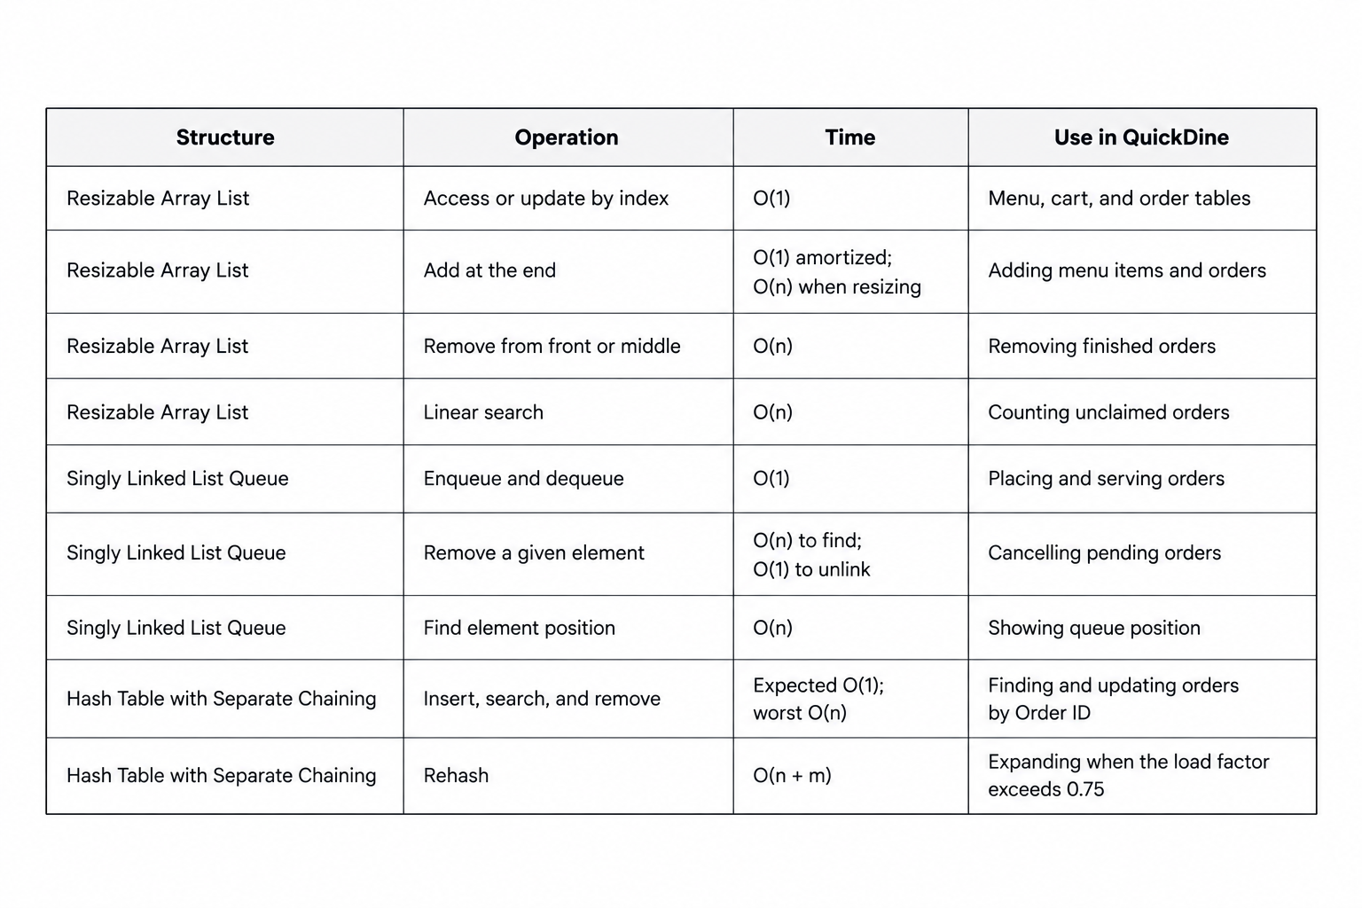
Note. n = number of elements. Complexities follow Cormen et al. (2022) and Skiena (2020). The "Use in QuickDine" column describes the group's application.
Table 1 shows that the three structures have complementary strengths. The array list is best at indexed access and appending, the linked queue at adding and removing at its ends, and the hash table at direct retrieval by key. Each also has an operation that grows with the number of elements: removal from an array list, finding a position in a queue, and the worst case of a hash table. These costs are acceptable for QuickDine because the registry holds only active orders, and they are the points that Chapter Four examines through pseudocode, tests, and benchmarks.

Synthesis and Project Gap
The reviewed literature agrees on the problem. University dining services become congested when customer demand exceeds the service capacity available at peak periods, and queue management is a recognized way to respond. Kambli et al. (2020) and Usluer (2025) approached this problem through simulation of capacity and queue-management decisions, and Usluer found that reallocating capacity was the most effective strategy among the scenarios tested. Bari et al. (2025) described the same conditions in college canteens, namely long lines, slow service, and crowded spaces at peak hours. These studies establish why a canteen needs organized order handling, but they mainly evaluate staffing and service capacity. They do not provide the order-handling logic of an application that records, sequences, and retrieves individual orders.
The related systems address that need through digital ordering. Table 2 compares them using the features that matter to QuickDine. Ardani and Aji (2024), Nwekori and Ignatius (2025), and Abdul Rahman and Othman (2024) developed web-based ordering systems for students, vendors, or teachers. Bhattarai et al. (2024) and Dey and Dey (2024) used QR codes and mobile devices, and Dey and Dey also generated an Order ID for each transaction. Bari et al. (2025) and Surbakti et al. (2023) addressed the order of service through tokens, a priority queue, and First Come, First Served scheduling, while Putera et al. (2025) examined numbered tags for physical queues.
Table 2
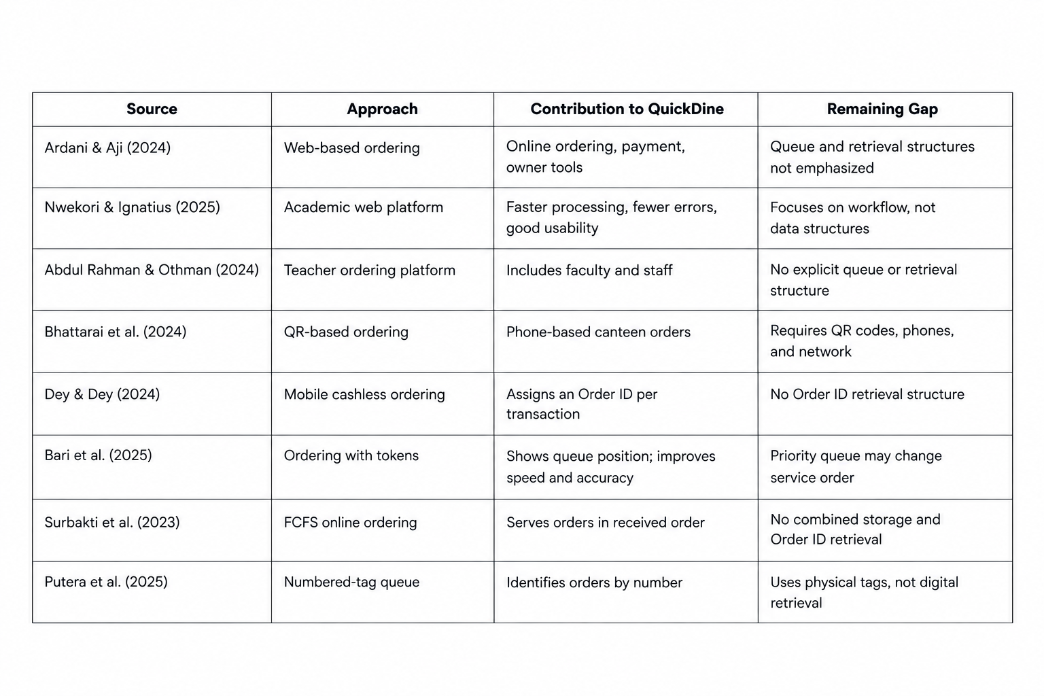
Comparison of Reviewed Systems and the Remaining GapNote. Descriptions summarize the studies as reviewed in Section 2.2. "Remaining gap" refers to features that the reviewed sources do not emphasize, and it does not claim that no other system provides them.
Table 2 shows that the existing systems provide digital ordering, order identification, and some form of sequencing, but they differ from QuickDine in emphasis. Most are web, QR, or mobile platforms whose reported strengths are convenience, payment, and usability. The sources that deal with sequence use tokens, a priority queue, scheduling, or physical tags. Among the sources reviewed, none presents an order-handling application whose sequencing, record storage, and Order ID retrieval are each assigned to a separately implemented data structure and then tested and measured. This is not a claim that such systems do not exist. It describes the gap that this project addresses within the scope of a Data Structures and Algorithms course.
The technical literature in Section 2.3 explains how to close this gap with linear structures. A queue on a singly linked list preserves the sequence of orders with constant-time enqueue and dequeue and allows a pending order to be cancelled by unlinking its node (Cormen et al., 2022; Skiena, 2020). A resizable array list holds the changing set of order records and supports indexed display in tables, with amortized constant-time addition (Cormen et al., 2022; Oracle, 2021a). A hash table with separate chaining and a bounded load factor retrieves an order by its Order ID in expected constant time, which avoids scanning every record (Cormen et al., 2022; Oracle, 2021b; Wengrow, 2020). Because the three structures hold references to the same order objects in the Java heap (Lindholm et al., 2021), they can work together without duplicating the records.
QuickDine therefore addresses the gap in the following way. Orders are processed in first-in, first-out sequence through a singly linked list queue, and the staff can start preparing an order only by serving the oldest pending order. Active order records are stored in an array list that feeds the staff and student tables. Each order is also placed in a hash table under its unique Order ID, so a student can track an order and staff can change its status through the path Pending, Preparing, Ready for Pickup, and Claimed, or cancel it while it is still Pending. The application is a stand-alone Java program with a graphical user interface and separate student and staff screens. An account database is used only for log-in, and the orders themselves are kept in memory in the three structures.
The limits of this contribution are also stated. QuickDine does not use priority queues, online payment, QR codes, or a waiting-time estimate. It does not claim to reduce actual waiting time or staff workload in a real canteen, because Chapter One limits the evaluation to the correctness and technical performance of the selected structures and functions. This synthesis leads directly to the objectives of Chapter One on the singly linked queue, the array list, and the hash table, and to the design and testing in Chapters Three and Four.
Initial Conceptual or System Framework
Figure 1 shows the input–process–output framework of QuickDine and the data structure used in each process.

Figure 1
Input–Process–Output Framework of QuickDine
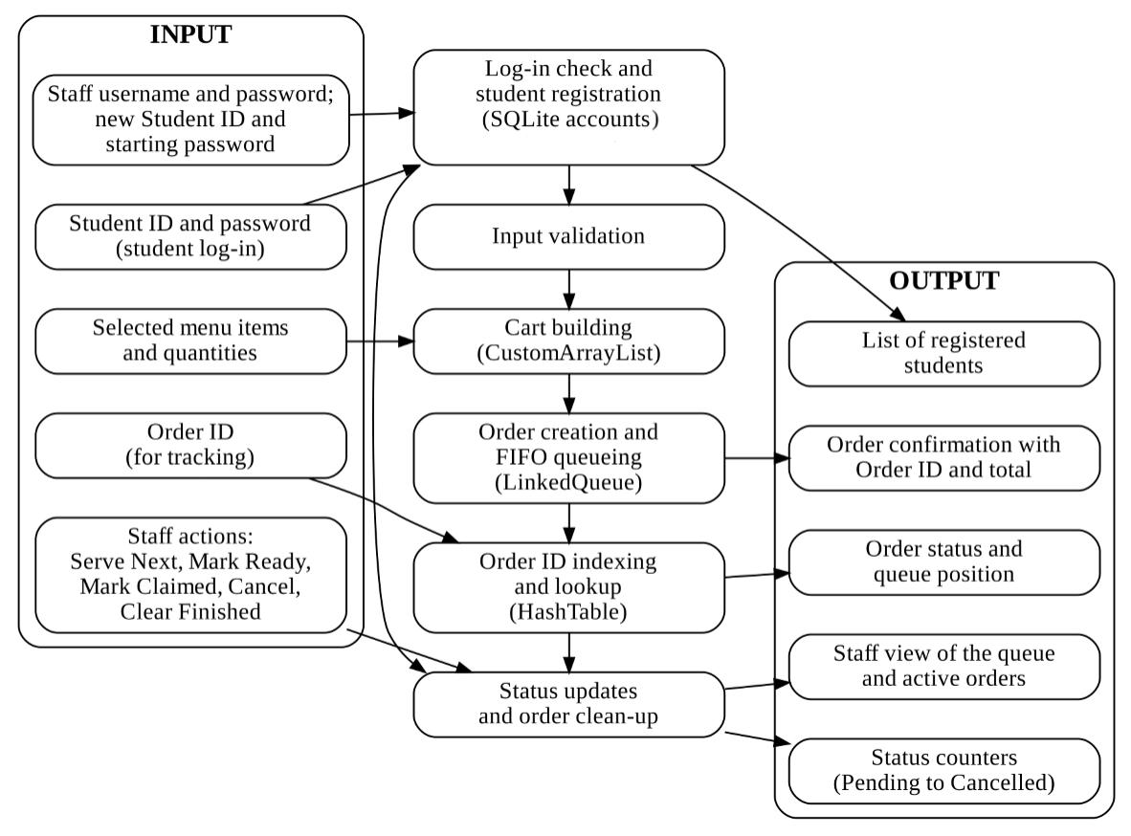

Input
The system receives five kinds of input: the student's Student ID and password; the menu items and quantities selected for the cart; the Order ID typed when tracking an order; the staff username and password, together with the Student ID and starting password of a student to register; and the staff actions Serve Next Order, Mark Ready, Mark Claimed, Cancel Order, and Clear Finished.
Process
Nobody can use the ordering or staff screens before the log-in check. Every input then passes through input validation, which blocks invalid characters while typing and checks the complete value on submission. The cart is built in a CustomArrayList, where adding the same item again updates its quantity. When the order is placed, it receives an Order ID and is added to the registry, enqueued at the rear of the LinkedQueue, and inserted into the HashTable under its Order ID. Order tracking and staff status updates use the HashTable to find the order directly. Serving takes the order at the front of the queue, cancellation unlinks a pending order from the queue, and clearing removes finished orders from the registry and the hash table. Orders are placed only under the Student ID of the logged-in student, who may have at most three unclaimed orders, and staff actions are accepted only from a logged-in staff member.
Output
The student receives an order confirmation with the Order ID and total and can view the status and queue position of their own orders. The staff see the queue from front to rear, the list of active orders, counters for each status, and the list of registered students.
The framework matches the current version of the project: it contains no waiting-time estimate, no sorting by Student ID, and no order database (the database holds log-in accounts only), and every process in it is implemented in the working application.

References:

Ardani, D., & Aji, A. S. (2024). Development of a Web-Based Food and Beverage Ordering System for university canteens using the LaRaVel Framework at University of Technology Yogyakarta. Journal of Scientific Research Education and Technology (JSRET), 3(4), 1462–1474. https://doi.org/10.58526/jsret.v3i4.521
Bari, P., Patil, Y., Sathawane, N., Suroshe, T., & Patil, A. (2025). Deploying an intelligent online food ordering system to optimize college canteen operations. International Conference on Futuristic Technology (INCOFT), 263–268. https://doi.org/10.5220/0013613700004664
Bhattarai, I. B., Bhandari, A., Pokhrel, N., Adhikari, A., & Baral, H. P. (2024). QR-based canteen Management system. Journal of Information Technology and Digital World, 6(3), 217–227. https://doi.org/10.36548/jitdw.2024.3.001
Dey, N., & Dey, T. (2024). An approach to Cashless Canteen Mobility Solution. An Approach to Cashless Canteen Mobility Solution, 14–19. https://doi.org/10.1109/ivit62102.2024.10692492
Kambli, A., Sinha, A. A., & Srinivas, S. (2020). Improving campus dining operations using capacity and queue management: A simulation-based case study. Journal of Hospitality and Tourism Management, 43, 62–70. https://doi.org/10.1016/j.jhtm.2020.02.008
Nwekori, F., & Ogbaga, I. (2025). Design and implementation of a Web-Based food Ordering platform for academic environments. Journal of Digital Food Energy & Water Systems, 6(2). https://doi.org/10.36615/918nh382
Rahman, D. S. A., & Othman, M. (2024, December 9). Food ordering system in the school canteen for teachers. https://publisher.uthm.edu.my/periodicals/index.php/aitcs/article/view/16382
Surbakti, E. E., Rizky, N., Pane, I. Z., & Khouwira, F. (2024). Efficient Order Management: Design and Implementation of a System using Scheduling Algorithms and Expert Validation. Ultimatics Jurnal Teknik Informatika, 15(2), 115–121. https://doi.org/10.31937/ti.v15i2.3489
Usluer, F. O. (2025). Solving Queue Problems in a Campus Dining Service with Discrete Event Simulation. Ege Akademik Bakis (Ege Academic Review), 25(2), 351–360. https://doi.org/10.21121/eab.20250207
Yinuo. (2026, January 29). GOAL OF THE MONTH – Goal 8: Decent work and Economic growth - United Nations Sustainable Development. United Nations Sustainable Development. https://www.un.org/sustainabledevelopment/goal-of-the-month-goal-8-decent-work-and-economic-growth/

RUBRIC A: MIDTERM PROJECT OUTPUT (Application, Paper, Hard Copy,
and Soft Copy)
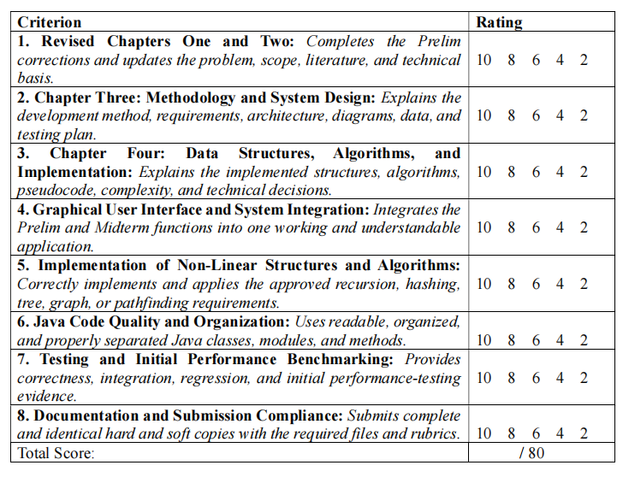

RUBRIC B: GROUP DEFENSE AND PRESENTATION
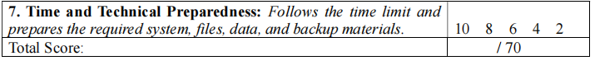
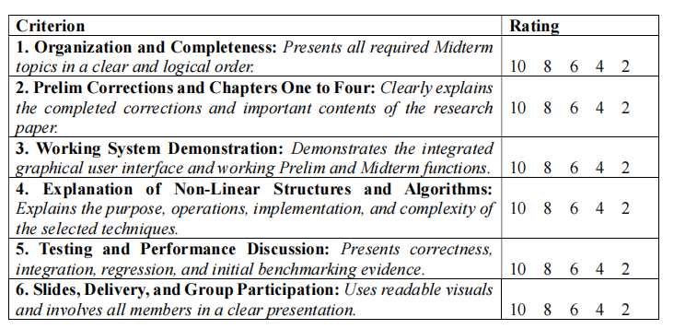

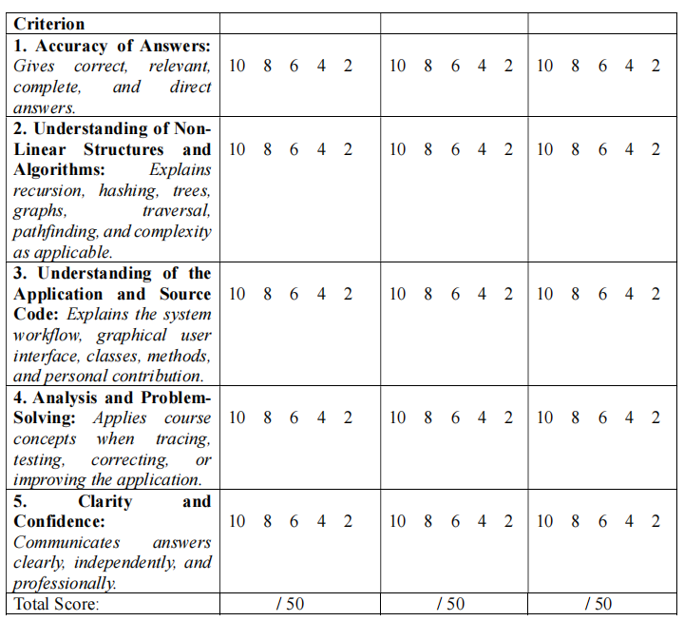
RUBRIC C: INDIVIDUAL QUESTION-AND-ANSWER PERFORMANCE

Chapter III

Development Method
The development of QuickDine followed an iterative and incremental process, from the initial proposal to the midterm implementation. The project began with planning and analysis, where the group identified the core problems of manual food ordering and queue management in the university canteen. This phase involved defining the project's scope, objectives, and the specific data structures required to address the identified inefficiencies.
Planning and Analysis
The group began by examining the current manual food ordering process in the university canteen. This involved identifying the problems experienced by students, faculty members, and canteen staff, such as long lines during breaks, slow service, and difficulty in tracking orders. These problems were discussed in Chapter 1, where the group established that manual ordering requires customers to wait in line, state their orders, and wait while the orders are recorded and prepared. Canteen personnel must receive orders, record the requested items, arrange the order sequence, and prepare meals at the same time. From this analysis, the group defined the functions that QuickDine needed to provide. The group also decided on the data structures to use: a singly linked queue for first-in, first-out order processing, an ArrayList for storing order records, and a hash table for retrieving orders by Order ID. These decisions were based on the requirements and supported by the related literature, which showed that digital ordering systems can reduce manual recording and speed up order processing.

Design Phase
During the design phase, the group created the system architecture and planned how the different parts of the application would connect. The group decided to build two separate windows: the Customer Interface for students and teachers, and the Staff Panel for canteen personnel. This separation ensures that customers cannot access staff panel functions and makes each interface simpler for its intended users. The group also designed the graphical user interface using Java Swing and planned the classes needed for the system, including the custom data structures and the service classes that would handle order operations. The design was guided by the project scope, which stated that the primary users of QuickDine are students and canteen staff, and that the two interfaces will have different access permissions to prevent customers from accessing staff panel functions.
Implementation. The group implemented the custom data structures first because they are the foundation of the system. The CustomArrayList was built to store and manage order records as the number of orders changes. The CustomQueue was built as a singly linked list to hold pending orders in first-in, first-out sequence. The HashTable was built with separate chaining to map each Order ID to its order record. After the data structures, the group developed the application logic in the OrderService class, which connects the data structures and handles all order operations such as placing, serving, cancelling, and tracking orders. The LoginService and AccountDatabase classes were then built to handle user authentication using an SQLite database. Finally, the group built the graphical user interface, starting with the login screen and then creating the customer and staff windows.
Testing and Debugging
Testing was done continuously as each part of the application was built. The group tested the custom data structures separately to verify their correctness and performance. For example, the queue was tested to ensure that orders are processed in the correct first-in, first-out sequence. The hash table was tested to confirm that orders can be retrieved quickly using their Order IDs. The group also tested the full application by simulating scenarios such as placing orders, serving them, tracking them, and handling error conditions. When problems were found, the group fixed them and tested again. For example, input validation was added to prevent invalid IDs and passwords. The testing was guided by the project objectives, which requires the group to test the functionality, correctness, reliability, usability, and response time of the queue management, order storage, order retrieval, and order-status modules.
Review and Revision
At the end of each phase, the group reviewed the work against the project objectives. This review confirmed that every required function was implemented and that the system matched the defined scope. Features that were not part of the plan were not added. The review also helped the group identify areas that needed improvement. For example, the group decided to remove the waiting-time estimate feature because it was not part of the final scope and does not make sense. The group also confirmed that the system does not include inventory monitoring, supplier management, employee management, or detailed financial reporting, as stated in the limitations. The review ensured that the application remained focused on its primary purpose of providing an organized food ordering and queue management system for the university canteen.
System Requirements
The system requirements specify what QuickDine is intended to provide and the qualities which the system should keep during its use. Functional requirements state what the system should be able to do, and non-functional requirements set out the qualities and conditions under which the functions should be performed.

Table 1
Functional requirements that describes the expected capabilities of Quickdine
ID | Requirement | Related Objective
FR-01 | The system shall allow canteen staff to log in using an assigned username and password. . | System functionality and access management
FR-02 | The system shall allow a logged-in customer to browse the menu and add items with quantities to a cart. | Efficient order placement
FR-03 | The system shall display the cart contents, including item subtotals and total cost, and allow item removal. | Efficient order placement
FR-04 | Upon placing an order, the system shall generate a unique Order ID in the format "QD-XXXX". | Order identification and tracking
FR-05 | The system shall add each new order to the end of a queue for processing. | First-in, first-out order processing
FR-06 | The system shall store each new order in an ArrayList that keeps all active order records. | Order record management
FR-07 | The system shall store each new order in a hash table using its Order ID as the key. | Fast order retrieval
FR-08 | The Staff Panel shall display the queue of pending orders in first-in, first-out order. | First-in, first-out order processing
FR-09 | The Staff Panel shall allow staff to serve the next pending order, which removes it from the queue and marks it as "Preparing". | Order management
FR-10 | The Staff Panel shall allow staff to update an order from "Preparing" to "Ready for Pickup" and from "Ready" to "Claimed". | Order status management
FR-11 | The Staff Panel shall allow staff to cancel any order that is still in "Pending" status. | Order management
FR-12 | The Customer Interface shall allow a customer to track their order by entering an Order ID and see its status and queue position. | Order tracking
FR-13 | The system shall limit the Staff Panel and its functions to users with a valid staff account. | Access management
FR-14 | The system shall check all user inputs (IDs, passwords, Order IDs, quantities) and reject invalid or incomplete entries. | Input validation and error handling

Table 2
Non-Functional Requirements that specify the expected Operation pf QuickDine
ID | Requirement | Verification Method
NFR-01: Usability | The graphical user interface shall provide clearly labeled controls and understandable navigation for customers and staff. | Conduct usability testing.
NFR-02: Correctness | The system shall process orders in the correct first-in, first-out sequence and retrieve orders by Order ID correctly. | Compare system outputs with manually calculated expected results.
NFR-03: Performance | The system shall complete order placement, retrieval, and queue operations within the time limits established for the test dataset | Measure execution time using a predefined dataset.
NFR-04: Reliability | The system shall handle valid inputs without unexpected termination and display appropriate messages for invalid inputs. | Perform normal-operation and invalid-input tests.
NFR-05: Security | The system shall store passwords as salted hashes so the actual password cannot be read from the database. | Verify that the database stores only hashed values and not plain-text passwords.
NFR-06: Compatibility | The system shall work as a standalone Java desktop application without needing an internet connection for its main functions. | Test the application on a computer with no network connection.
NFR-07: Maintainability | The code shall be organized into clear classes with specific jobs so that future changes are easier to make. | Review the code structure and class responsibilities.
System Architecture
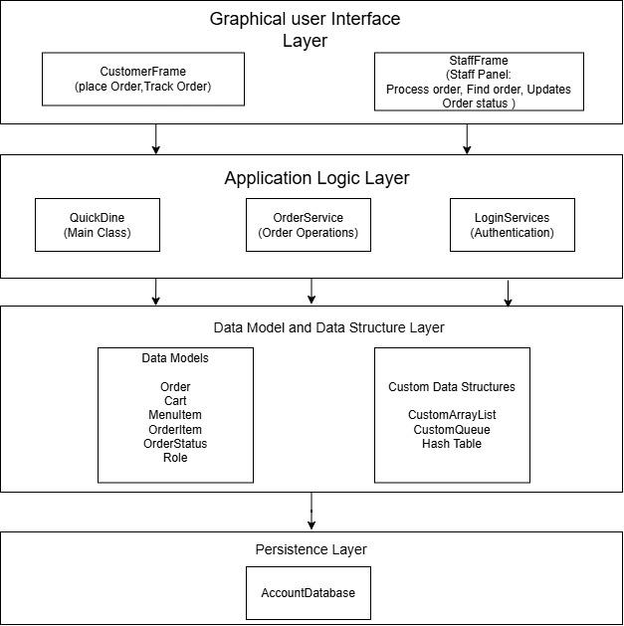
The QuickDine system is organized into four main layers. This design separates the different parts of the application so each one has a clear purpose and can be maintained easily. The architecture is based on the input-process-output framework, which shows how QuickDine receives input, processes it using the selected data structures, and produces output for the customer and staff. The architecture also reflects the scope and limitations, which stated that the system will use a custom queue, an ArrayList, and a hash table, and that the database will hold log-in accounts only.

Figure 1: System Architecture

Graphical User Interface
The Graphical User Interface Layer is the topmost layer and is what users see and interact with. It is built using Java Swing and consists of two main windows: CustomerFrame for students and teachers, and StaffFrame for canteen staff. A LoginFrame appears first, and the system opens the correct window based on the user's role. The GUI is responsible for displaying information to the user and collecting their input, such as menu selections, button clicks, and text entries. The GUI also displays error messages and success confirmations, which helps users understand what happened.
Application Logic Layer
The Application Logic Layer contains the main logic of the system. The QuickDine class starts the program and manages the connection between the login screen and the two main windows. The OrderService class handles all order operations, including placing orders, serving them, cancelling them, and finding them by Order ID. The LoginService class handles login, registration, password reset, and user session information. This layer acts as the bridge between the GUI and the data structures.
Data Model and Data Structure Layer
The Data Model and Data Structure Layer holds the core data handling of the system. It has two parts. The data models include simple classes and records such as Order, MenuItem, OrderItem, Cart, and OrderStatus that define how data is structured. The custom data structures include the CustomArrayList, CustomQueue, and HashTable. These are the specialized structures that directly address the project's data structures and algorithms objectives. The CustomArrayList stores the menu and the registry of all active orders. The CustomQueue holds pending orders in first-in, first-out sequence. The HashTable maps each Order ID to its order record for fast retrieval.
Data Persistence
The Persistence Layer handles long-term data storage. The AccountDatabase class uses an SQLite database file called quickdine.db to store user accounts. Each account record contains the username, which can be a Student ID, Teacher ID, or staff username, a salt, a password hash, and a role. The password itself is never stored; only its salted SHA-256 hash is saved. Active orders are stored only in memory and are not saved to the database, as stated in the project's limitations.
Information Flow
The flow of information in QuickDine follows a clear path. A user opens the system and sees the login screen. They enter their ID or username and password. The LoginService checks these credentials against the AccountDatabase. If the login is successful, the system opens either the CustomerFrame for students and teachers or the StaffFrame for staff. A customer selects menu items and adds them to a cart. When the customer places the order, the OrderPanel calls the OrderService.placeOrder method. The OrderService creates a new Order object and adds it to three data structures at once: the registry, which is a CustomArrayList, the queue, which is a CustomQueue, and the index, which is a HashTable. When a staff member uses the Serve Next Order button, the StaffPanel calls OrderService.serveNextOrder, which removes the first order from the queue and changes its status to Preparing. When a customer tracks an order, the TrackPanel calls OrderService.findOrder, which uses the hash table to find the order quickly by its Order ID.
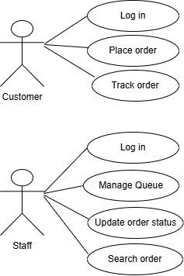
Use Cases and User Flow

Figure 2: Use Case Diagram
This figure presents the interactions between Customers, Staff, and the QuickDine system. Solid lines indicate associations between actors and their respective functions. Customers can log in, place orders, and track their orders. Staff can log in, manage the queue, update order statuses, and search for orders These relationships illustrate how orders are placed, processed, and tracked.

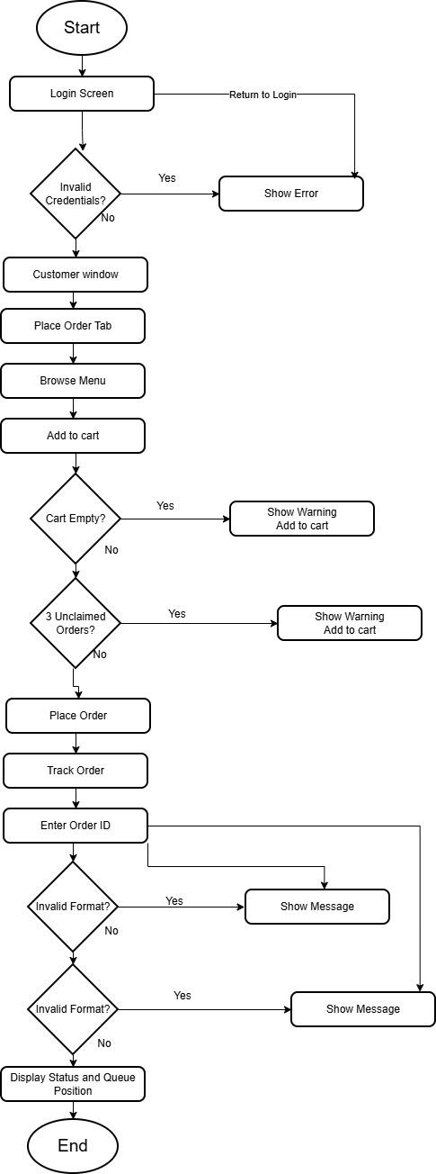

Figure 3: Customer Use Case Diagram
Customer Use Case
QuickDine has two primary actors: the Customer, which includes students and teachers, and the Canteen Staff. Each actor has specific actions, decisions, results, and possible error conditions. The use cases are based on the scope, which stated that students will use the Customer Interface to select food items, submit orders, and check their order status, while canteen staff will use the Staff Panel to view incoming orders, serve the next pending order, update order statuses, cancel pending orders, and clear finished records. The customer begins by logging in through the LoginFrame. If the customer is new, the system automatically creates an account on the first login. If the customer enters an invalid ID format or an incorrect password, the system displays an error message and the customer remains on the login screen. After a successful login, the customer can access the Place Order and Track Order tabs.
Place Order Flow
In the Place Order tab, the customer browses the menu and adds items with quantities to the cart. The system displays the cart contents and total cost. If the customer tries to place an order with an empty cart, the system shows a warning. If the customer already has three unclaimed orders, the system explains that they must claim one first before ordering again. When the order is placed successfully, the system generates a unique Order ID and displays a confirmation with the Order ID, items, total, and queue position.
Track Order Flow
In the Track Order tab, the customer can enter an Order ID to check the status and queue position. The system validates the Order ID format. If the format is wrong, a hint appears. If the format is correct but the order does not exist or does not belong to the customer, the system displays a not found message. The customer can also click on any of their own orders in the My Orders list to view its details without typing the Order ID.
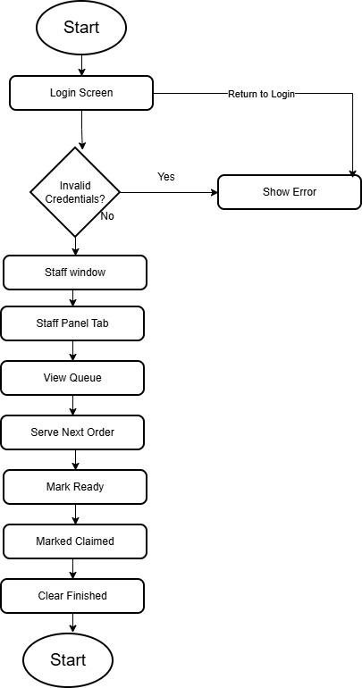

Figure 4: Staff Use Cases
Staff Use Cases
The staff member logs in through the same LoginFrame but selects the Staff role. The system validates the username and password against the database. If the credentials are incorrect, the system displays an error and keeps the staff member on the login screen. After a successful login, the staff member can access the Staff Panel.
Staff Panel Flow
In the Staff Panel, the staff member views the queue of pending orders in first-in, first-out order. The staff member can click Serve Next Order to process the first order in line, which removes it from the queue and marks it as Preparing. If the queue is empty, the system shows a message. The staff member can also select an order from the Active Orders table and mark it as Ready for Pickup or Claimed, or cancel it if it is still pending. The system validates the current status before allowing a change. For example, an order can only be marked Ready if it is currently Preparing. The staff member can search for an order by entering its Order ID. The system uses the hash table to find the order and highlights it in the table.
Error Conditions
The system handles error conditions at every step. These include invalid login credentials, invalid ID formats, empty carts, attempts to exceed the unclaimed order limit, invalid order status changes, and attempts to access staff functions without a staff account. In each case, the system displays a clear message and prevents the invalid action.

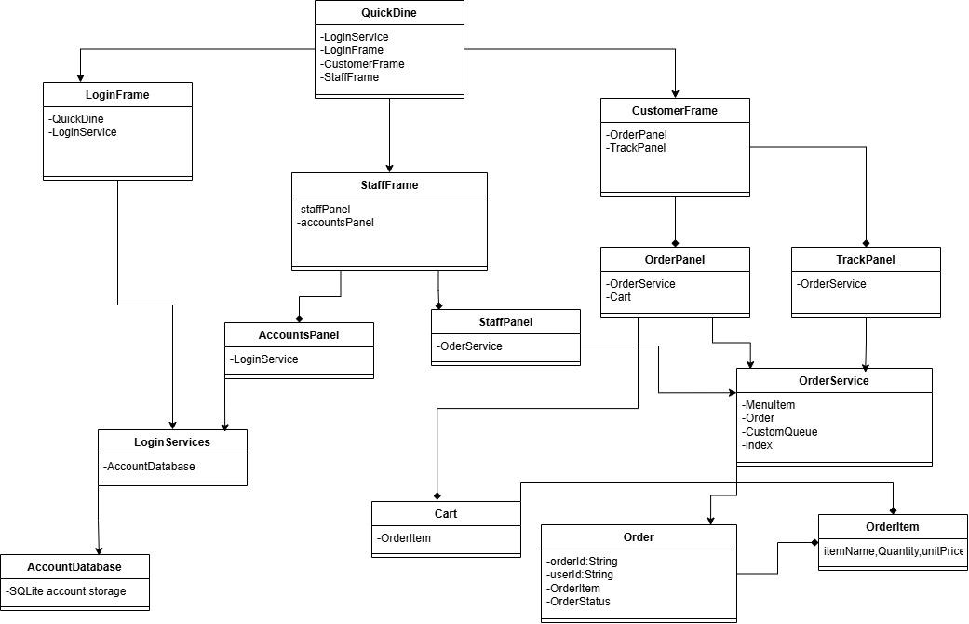
Class Diagram

Figure 5: Class Diagram
The class diagram presents the main classes and relationships of QuickDine, illustrating user authentication, order management, queue processing, and data structure operations. It also shows the use of custom data structures to support data management and system operations.
The main class is QuickDine, which connects the login screen and the two main windows. The QuickDine class has a LoginService, a LoginFrame, a CustomerFrame, and a StaffFrame. The CustomerFrame class represents the window for students and teachers. It contains an OrderPanel and a TrackPanel. The StaffFrame class represents the window for canteen staff. It contains a StaffPanel and an AccountsPanel.
The OrderService class is the central class for order operations. It owns the three custom data structures: a CustomArrayList for the menu, a CustomArrayList for the registry of all active orders, a CustomQueue for pending orders, and a HashTable for the order index. It has methods to place an order, serve the next order, mark an order as ready, mark an order as claimed, cancel an order, clear finished orders, find an order by Order ID, find an order of a specific user, get the queue position of an order, get the pending orders, get the registry, get the orders of a user, count unclaimed orders, count orders by status, and get the menu.
The LoginService class handles authentication and user sessions. It has a reference to the AccountDatabase and a reference to the current account. The AccountDatabase class handles the SQLite database. It has methods to find an account by username, insert a new account, update a password, count accounts by role, list all customer accounts, and close the connection.
The CustomQueue class is a generic singly linked queue. It has references to the front and rear nodes and a size counter. The CustomArrayList class is a generic resizable array list. The HashTable class is a generic hash table with separate chaining. Both the CustomQueue and the HashTable use a private Node class for their internal structure.
The data models include the Order class, the Cart class, the MenuItem record, the OrderItem record, the OrderStatus enumeration, and the Role enumeration. The Order class has an order ID, a user ID, a list of order items, a total, a placed-at time, and a status. The Cart class has a list of order items. The MenuItem record has a name and a price. The OrderItem record has an item name, a quantity, and a unit price. The OrderStatus enumeration has values for Pending, Preparing, Ready, Claimed, and Cancelled. The Role enumeration has values for Student, Teacher, and Staff.

Graphical User Interface Design
QuickDine uses a Java Swing graphical user interface that serves two types of users: customers (students and teachers) and canteen staff. Each user type has its own window, which keeps customer functions and staff functions separate. A login screen appears first, and the system opens the correct window based on the user's role. This section presents the main screens, their input controls, outputs, navigation, visualization areas, messages, and error handling.

Login Screen
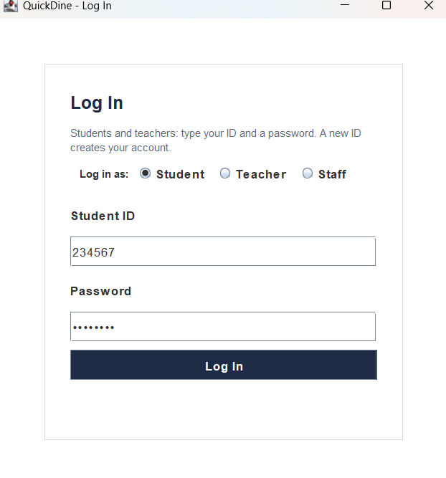
The login screen is the starting point of the system. It has radio buttons to choose a role, which can be Student, Teacher, or Staff. It has a text field for the ID or username, a password field, and a Log In button. The screen also shows a note explaining that new students and teachers can create an account on their first login. Error messages appear below the button in red text when something is wrong, such as an incorrect password or an invalid ID format. The password field hides what is typed.

Figure 1: Login Page

Customer Interface
The Customer Interface is for students and teachers. It has two tabs: Place Order and Track Order. The window has a header that shows the role and ID of the logged-in customer and a Log Out button. Closing the window logs the customer out.The Place Order tab has two main areas. The left side shows the menu items as cards in a grid. Each card displays the item name, price, a dropdown list to select quantity from 1 to 20, and an Add to Cart button.
The right side is the cart. It shows a table with columns for Item, Quantity, Price, and Subtotal. Below the table, the total price is displayed in large text. Buttons for Remove Selected and Clear Cart are provided, along with a large Place Order button. A label shows which user ID is currently ordering. When the customer places an order, a confirmation dialog appears showing the Order ID, items, total, and queue position. The dialog also asks if the customer wants to log out, since the computer may be shared.
The Track Order tab has a search area at the top with a text field for the Order ID and a Track button. Below the search area, there are labels showing the Order ID, Status, Queue Position, and Total. The status label changes color based on the order status. On the left side, a My Orders table lists all of the customer's own active orders. Clicking a row in this table shows its details without the customer needing to type the Order ID. On the right side, an Items table shows the individual items in the selected order.

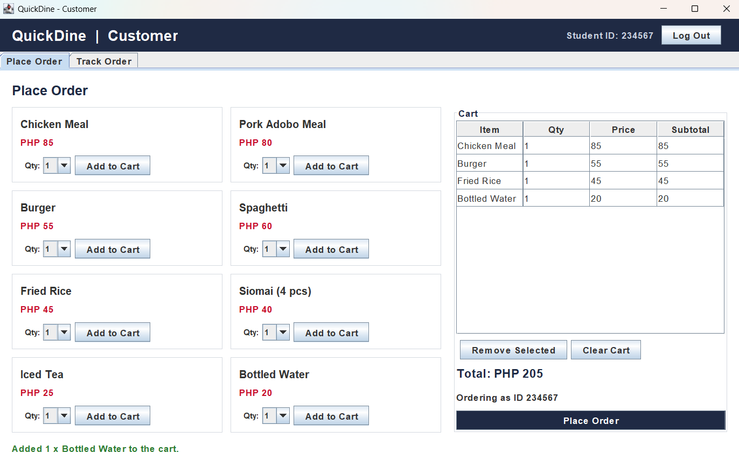

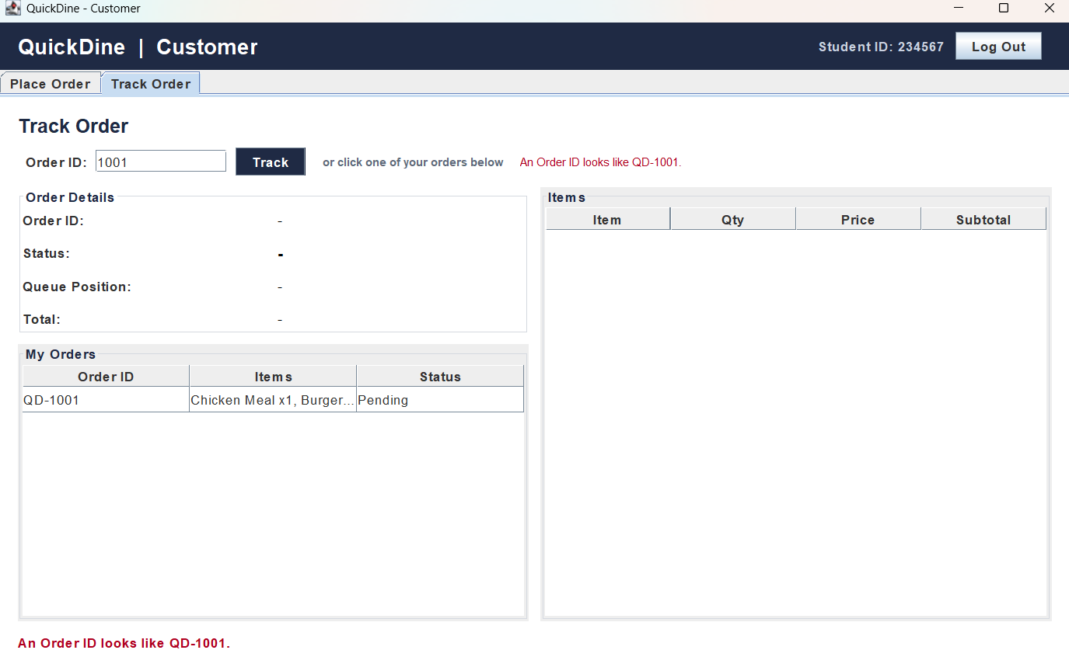
Figure 2: Customer Interface (Place order tab)

Figure 3: Customer Interface (Track order tab)

Staff Interface
The Staff Interface is for canteen personnel. It has two tabs: Staff Panel and Student and Teacher Accounts. The window has a header that shows the staff username and a Log Out button. Closing the window logs the staff member out. The Staff Interface is a different window from the Customer Interface, so customers never reach staff-only functions.
The Staff Panel tab has three main sections. At the top, five counter tiles show the total number of orders in each status: Pending, Preparing, Ready, Claimed, and Cancelled. Each counter is displayed in a different color that matches the status. On the left side, the Order Queue table shows pending orders with the first order at the top, following the first-in, first-out rule. A label below the table shows which order is next to serve and how many orders are waiting. A Serve Next Order button is placed below the label. On the right side, the Active Orders table shows all active orders in the system. Above this table is a search field where staff can enter an Order ID to find a specific order. Below the table are four buttons: Mark Ready, Mark Claimed, Cancel Order, and Clear Finished. The staff member selects an order from the table and then clicks the appropriate button to change its status. The system checks the current status before allowing a change and displays an error message if the change is not allowed.

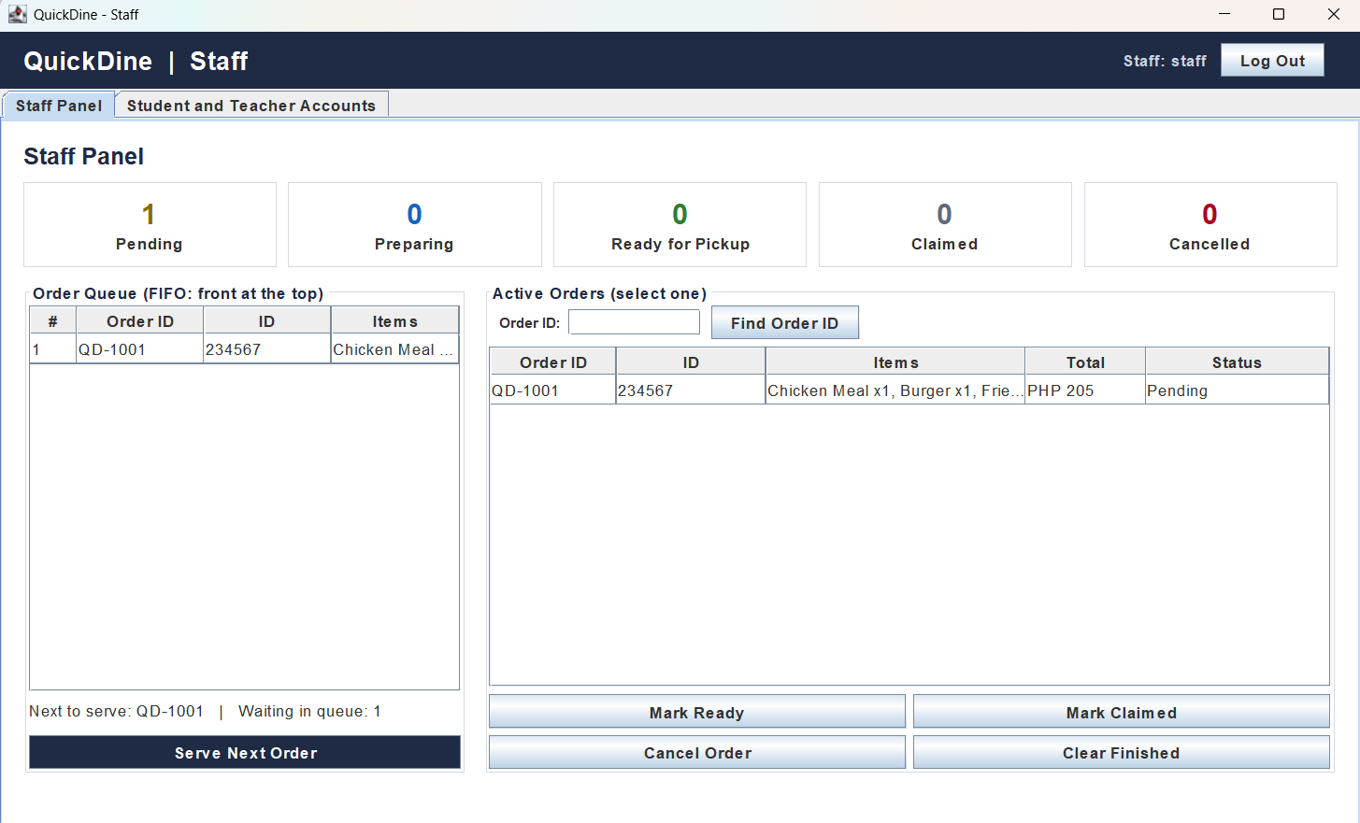

Figure 4: Staff Interface
Staff Interface: Student and Teacher Accounts Tab
The Student and Teacher Accounts tab has two areas. On the left, a form allows staff to register a new student or teacher. The staff member selects the role, enters the ID, and sets a password twice for confirmation. A Register Account button saves the new account. A Reset Password button allows staff to change the password of an existing user. On the right, a table lists all registered students and teachers, showing their role and ID. A counter below the table shows the total number of registered customers. The system validates the ID format and checks that the ID is not already registered before saving. Success and error messages appear at the bottom of the screen.

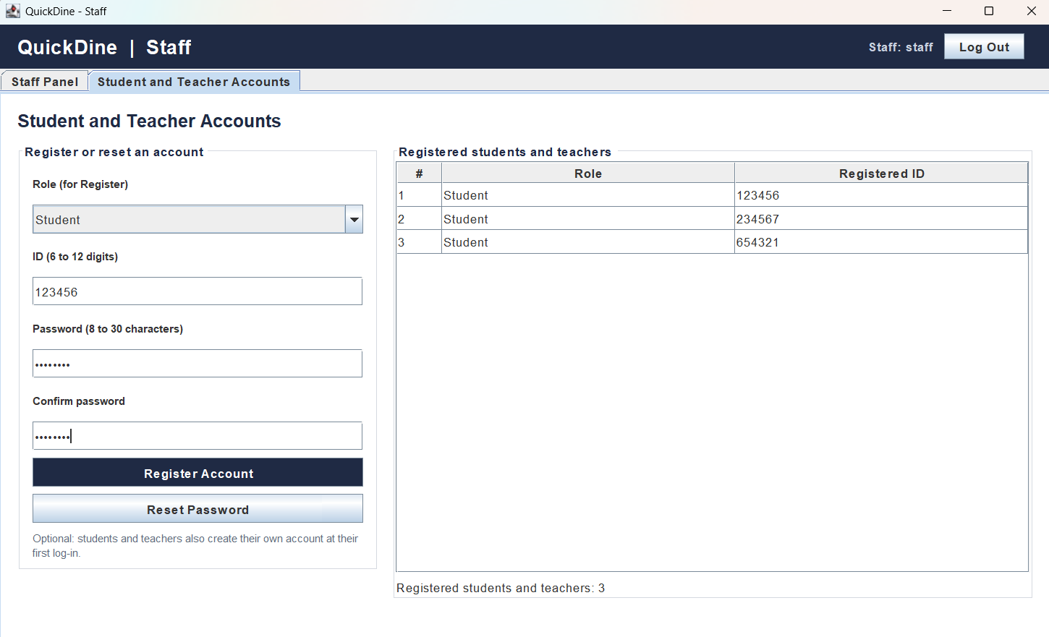

Figure 5: Student and Teacher Accounts tab

Messages and Error Handling
The system displays confirmation, warning, and error messages for the main actions. Table 1 summarizes them.
Table 1
Main error message
Screen | Condition | System Response
Login | Invalid ID format | "The ID must be 6 to 12 digits long."
Login | Incorrect password | "Incorrect password for this ID (or wrong staff login)."
Place Order | Empty cart | "The cart is empty. Add at least one item first."
Place Order | Three unclaimed orders | "You already have 3 unclaimed orders. Claim one first before ordering again."
Track Order | Invalid Order ID format | An Order ID looks like QD-1001."
Track Order | Order not found | "You have no active order with that Order ID."
Staff Panel | Empty queue | "The queue is empty. There is no pending order to serve."
Staff Panel | Invalid status change | "Only a Preparing order can be marked Ready for Pickup."
Staff Panel | Invalid cancellation | "Only a Pending order can be cancelled."
Accounts | Duplicate ID | "ID [ID] is already registered."
Accounts | Invalid password | "The password must be 8 to 30 characters long."
Accounts | Passwords do not match | "The two passwords do not match."
Accounts | Successful registration | "[Role] ID [ID] is now registered and can log in."

Data and Testing Plan
QuickDine uses three types of data: menu data, user account data, and order data. The menu data consists of the food items and their prices. The menu items and prices are hard-coded in the OrderService class. This represents a fixed menu for the project. Each menu item is a MenuItem record with a name and a price. The menu data is prepared for testing by reviewing the list of items and prices to ensure that they are correct and that each item has a valid name and price. The menu data is used in test cases that involve browsing the menu, adding items to the cart, and placing orders.
The user account data consists of the login information for students, teachers, and staff. User account information is stored in an SQLite database file called quickdine.db. Each record contains the username, which can be a Student ID, Teacher ID, or staff username, a salt, a password hash, and a role. The password itself is never stored; only its salted SHA-256 hash is saved. This data is created when a student or teacher logs in for the first time, or when the system creates the default staff account on the first run. The user account data is prepared for testing by creating test accounts for students, teachers, and staff, and by testing the registration and password reset functions. The user account data is used in test cases that involve logging in, registering new accounts, and resetting passwords.
The order data consists of the orders placed by customers. Order information is stored in the custom data structures in the computer's memory while the program is running. This includes the Order ID, user ID, items, total, status, and time placed. The CustomArrayList stores all active orders in the order they were placed. The CustomQueue stores pending orders in first-in, first-out sequence. The HashTable maps each Order ID to its order record. This data is not saved to a database, as stated in the project limitations in Chapter 1. As a result, records may be lost when the server process is restarted. The order data is prepared for testing by placing test orders with different items, quantities, and user IDs, and by testing the queue operations, hash table lookups, and status updates. The order data is used in test cases that involve placing orders, serving orders, tracking orders, and clearing finished orders.
Test Type | Testing Procedure | Expected Result
Correctness | Enter valid data, place orders, serve orders, and track orders. | Records are saved, orders are processed in the correct sequence, and results are displayed correctly.
Invalid Input | Enter incorrect credentials, empty fields, duplicate IDs, and invalid Order IDs. | Invalid inputs are rejected or handled appropriately with clear error messages.
Boundary | Test IDs with minimum and maximum lengths, passwords with minimum and maximum lengths, and the unclaimed order limit. | The system handles boundary conditions without incorrect results or crashes.
Integration | Test the connection between the interface, application logic, data structures, and database. | Data are processed and transferred correctly between components.
Regression | Repeat previously successful tests after changes. | Existing functions continue to work correctly.
Initial Performance | Measure the time required to place, search, and retrieve orders using different sample-data sizes. | Operations complete correctly within reasonable time under the testing conditions.

Requirements Traceability
The requirements traceability matrix links QuickDine's objectives to its functional requirements, graphical user interface, program modules, data structures, algorithms, and test cases. It provides a basis for verifying whether the implemented features support the project's objectives. Test results will be recorded after the corresponding test cases have been executed. The matrix connects each objective to the relevant system components and testing procedures. The results column remains pending until testing has been completed and documented.

Chapter IV
Data Structures, Algorithms, and Implementation
This chapter explains how the data structures and algorithms of QuickDine are implemented in the Java source code. It covers the two linear structures kept from the Prelim Term, the queue built on a singly linked list and the resizable array list, and the structure added in the Midterm Term, the hash table with separate chaining. For each structure, it states the system requirement it addresses, the information it stores, its important operations, the reason it was selected and the alternative that was considered, its time and space complexity, its strengths and limitations, its connection to the Java classes and the graphical user interface, and the tests that verify it. Pseudocode is given for every major operation, and Java code is quoted only where it explains an implementation decision. The chapter ends with the supporting algorithms, the way the three structures work together, a pilot benchmark, and the verification results.

Overview of the Implementation
All three data structures were written by the group without using the Java Collections Framework. They are generic classes, so the same code stores orders, order items, menu items, buttons, and account rows, while the compiler checks that the correct type is used (Gosling et al., 2021). The windows never change a structure directly: every button calls a method of OrderService, Cart, or LoginService, and those classes update the structures. This follows the layered architecture described in the System Architecture section of Chapter III. Table 3 lists each structure and algorithm with the functional requirement it serves, the class that contains it, the window function that uses it, and its tests.
Table 3
Data Structures and Algorithms Implemented in QuickDine
Structure or Algorithm | Term | Requirement Served | Java Class | GUI Function | Tests
Queue on a singly linked list | Prelim (kept) | Serve pending orders first-in, first-out; show the queue and queue positions; cancel pending orders | CustomQueue<E>, used in OrderService | Place Order, Order Queue table, Serve Next Order, Cancel Order, queue position | QU-01 to QU-06; SV-04, SV-05, SV-08, SV-17
Resizable array list | Prelim (kept) | Hold the menu, cart items, order items, and active orders; show them in tables | CustomArrayList<E>, used in Cart, Order, OrderService, AccountDatabase, panels | Menu, cart, Active Orders, My Orders, registered accounts | AL-01 to AL-07; CT-01 to CT-04; SV-10, SV-14
Hash table with separate chaining | Midterm (new) | Retrieve an order by Order ID for tracking, status changes, search, and clearing | HashTable<V>, used in OrderService | Track Order, Find Order ID, Mark Ready, Mark Claimed, Cancel Order, Clear Finished | HT-01 to HT-07; SV-06, SV-07, SV-10, SV-13, SV-15, SV-16
Linear search of the registry | Midterm | My Orders, the three-order limit, and the status counters | OrderService | My Orders table, Place Order, status counters | SV-11, SV-12, SV-14, SV-17
Order status rules | Prelim (revised) | Allow only valid status changes | OrderService, OrderStatus | Staff Panel buttons | SV-06, SV-07, SV-09
Input validation by character scan | Prelim (revised) | Reject invalid IDs, usernames, passwords, Order IDs, and quantities | InputValidator, OrderItem | All input fields | VA-01 to VA-15; CT-02
Salted SHA-256 hashing and log-in | Midterm | Restrict each window to its role; store passwords safely | LoginService, AccountDatabase | Log In, Accounts tab | LG-01 to LG-18
Note. Test identifiers refer to the automated test cases in Table 13.
Table 3 shows that every structure serves a function that users reach through a window, and that every row has tests. The three structures do not hold separate copies of the orders. Each placed order is one Order object in the Java heap (Lindholm et al., 2021), and the registry, the queue, and the hash table each hold a reference to it, as Figure 2 shows. A status change made through one structure is therefore seen through the others at once, and memory grows by only a few references per structure for each order.
Figure 2
The Same Order Objects Referenced by the Three Data Structures
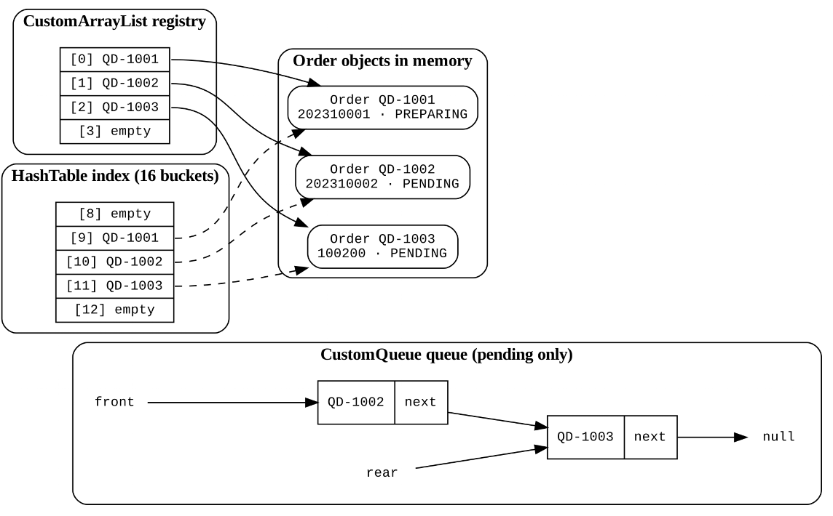
Note. State after QD-1001, QD-1002, and QD-1003 were placed and QD-1001 was served. Bucket indexes are the number in each Order ID modulo 16.
Queue Implemented as a Singly Linked List
Requirement addressed
Pending orders must be served in exactly the sequence in which they were placed, the Staff Panel must show them from front to rear, a customer must see the queue position of a pending order, and a pending order must be removable when it is cancelled. These requirements come from the third objective in Chapter I and the functional requirements in Chapter III.
Information stored
Only the orders whose status is Pending. Each node holds a reference to one Order and a reference to the next node. The class keeps a front reference (the next order to serve), a rear reference (the newest order), and a size counter. An order leaves the queue when it is served or cancelled, but it stays in the registry and the hash table.
Important operations
Enqueue adds a node after the rear; dequeue removes the front node and returns its order, or returns null when the queue is empty; peek returns the front order without removing it; remove unlinks a given order from any position, which is used for cancellation; indexOf counts nodes from the front until it reaches the order and returns −1 if the order is not queued; and toList copies the orders from front to rear into a CustomArrayList for the queue table. The pseudocode below follows the Java methods of CustomQueue.
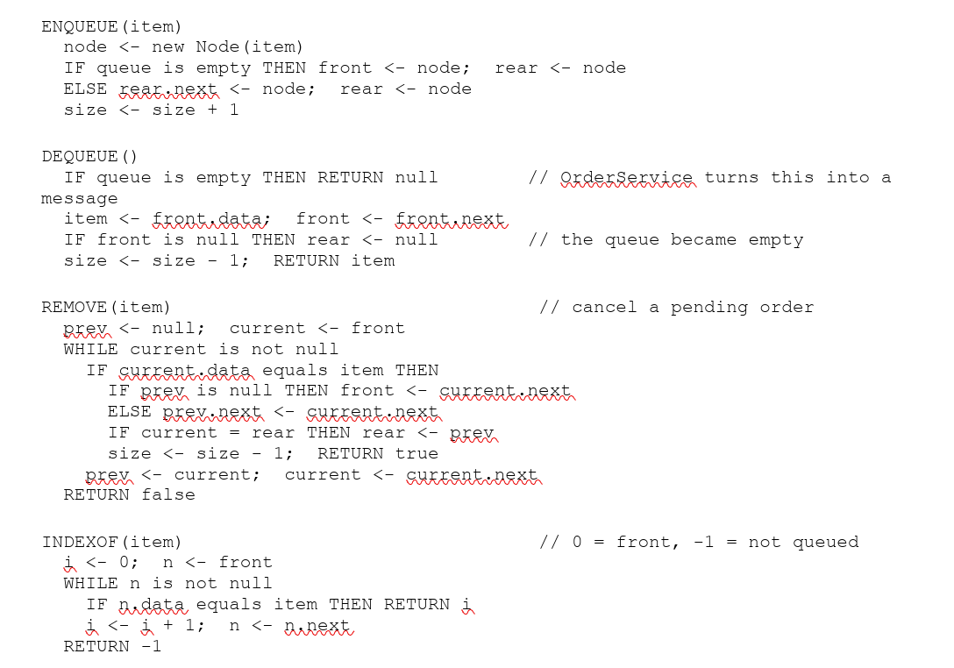
Figure 3 shows how REMOVE cancels an order in the middle of the queue. Only the next reference of the previous node changes; no other node is moved. The line IF current = rear THEN rear <- prev keeps the queue correct when the newest order is cancelled. Without it, rear would still point to the removed node, and the next ENQUEUE would attach the new order to a node that is no longer in the list. Test QU-04 removes the rear node and then enqueues another order to check exactly this case. OrderService turns the zero-based index into a queue position by adding one, so position 1 is the next order to serve and 0 means the order is no longer waiting.
Figure 3
Cancelling a Pending Order by Unlinking Its Node
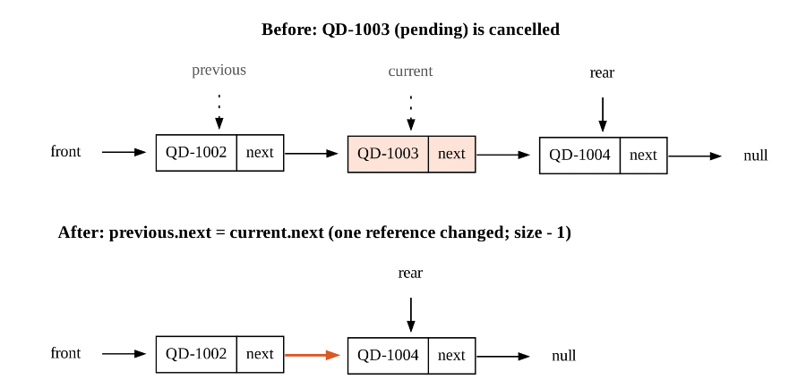
Reason for selection
A queue enforces first-in, first-out order by its design: the only way to take an order out for serving is dequeue, which always returns the oldest order (Wengrow, 2020). The Serve Next Order button calls only this operation, so the staff cannot skip an order. A linked list was chosen as the storage because both ends are reached through stored references, so adding and serving take constant time, the queue never becomes full, and a cancelled order can be removed by changing one reference.
Alternative considered
A circular array queue also gives O(1) enqueue and dequeue, but it has a fixed capacity that must be resized, and removing an order from the middle would require shifting every later element (Cormen et al., 2022). Keeping pending orders only in the registry and searching it for the oldest Pending order was also rejected, because serving would then take O(n) time and the first-in, first-out rule would depend on a search instead of on the structure.
Time and space complexity
Table 4 gives the complexity of each operation, where n is the number of pending orders. Enqueue and dequeue contain no loop, while remove and indexOf contain one loop that may visit every node.
Table 4
Complexity of the CustomQueue Operations
Operation | Steps That Determine the Cost | Time | Extra Space
enqueue, dequeue, peek, size, isEmpty | A fixed number of reference changes; no loop | O(1) | O(1)
remove(item) | Loop from the front until the order is found; unlinking itself is O(1) | O(n) worst case; O(1) if the order is at the front | O(1)
indexOf(item) | Loop from the front, counting nodes | O(n) worst case | O(1)
toList() | Visit every node once and add it to a CustomArrayList | O(n) | O(n) for the new list
Whole queue | One node object per pending order | – | O(n)
Strengths and limitations
The queue guarantees fair service, never needs resizing, and cancels an order without shifting. Its limitations are that each node needs an extra object and reference, so it uses more memory per element than an array; that the position of an order is found by traversal in O(n) time; and that it cannot support priority orders, which is listed as a limitation in Chapter I.
Connection to the Java classes and GUI
CustomQueue<E> contains a private static Node<E> class. OrderService holds one CustomQueue<Order> named queue: placeOrder calls enqueue, serveNextOrder calls dequeue, cancelOrder calls remove, getQueuePosition calls indexOf, and getPendingOrders calls toList. In the windows, the queue appears as the Order Queue table of the Staff Panel, the Serve Next Order and Cancel Order buttons, and the queue position shown on the Track Order tab and in the order confirmation.
Tests used to verify correctness
QU-01 checks first-in, first-out order; QU-02 checks dequeue and peek on an empty queue; QU-03, QU-04, and QU-05 check removal from the middle, from the rear, and of the only node; and QU-06 checks indexOf and a missing element. Through the service, SV-04 checks that Serve Next Order follows the queue, SV-05 checks the empty-queue message, SV-08 checks that a cancelled middle order leaves the queue, and SV-17 checks the queue positions.
Resizable Array List
Requirement addressed
The application must hold lists whose length is not known in advance and must show them in tables by row number: the menu, the cart items, the items of each order, the registry of active orders, each customer’s My Orders list, and the list of registered accounts. This is the fourth objective in Chapter I.
Information stored
The elements in an internal Object array called elements and the number of stored elements, called size. The array starts with four slots. The capacity is the length of the array, and the size is how many slots are used.
Important operations
Add stores an element in the first free slot and grows the array when it is full; get and set read and replace the element at an index; removeAt deletes the element at an index and shifts the later ones left; indexOf performs a linear search; remove combines indexOf and removeAt; clear empties the list but keeps its capacity; and the private resize method creates an array twice as long and copies the elements into it. The pseudocode below shows these operations.
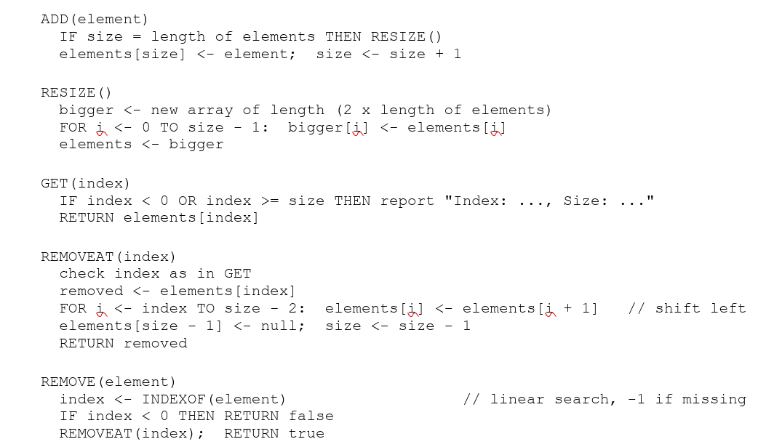
Figure 4 shows a resize. When the fifth menu item is added to a list of capacity four, RESIZE creates an array of eight slots and copies the four elements before the new one is stored.
Figure 4
Adding a Fifth Element to a Full Array List of Capacity Four
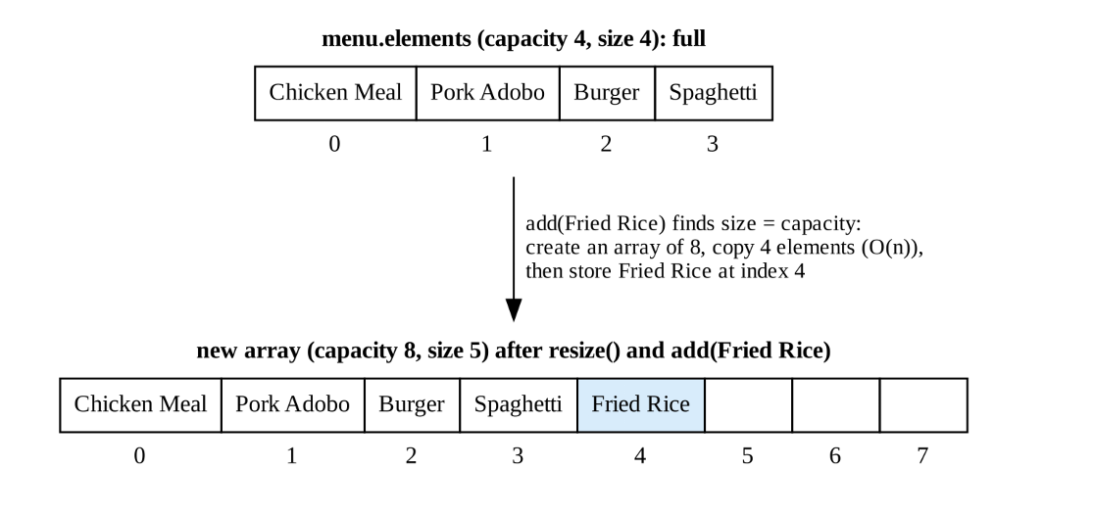
One implementation decision follows from a Java rule. Java does not allow a generic array to be created with new E[capacity], because the element type is not known at run time (Gosling et al., 2021). The class therefore stores its elements in an Object array and casts an element back to E when it is read. The cast is safe because add and set accept only E values, which is why the compiler warning is suppressed only on the reading methods, as the excerpt below shows.
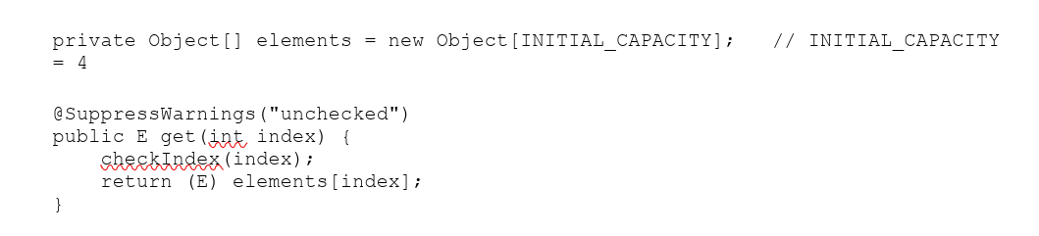
Reason for selection
Tables in the graphical user interface ask for rows by index, which an array answers in constant time. Most list operations in QuickDine add to the end or read by index, and both are fast in an array list. Doubling the capacity, rather than adding a fixed number of slots, keeps the total copying small: with doubling, n additions cost O(n) time in total, so each addition is O(1) amortized (Cormen et al., 2022).
Alternative considered
A fixed-size array was rejected because it fails when the number of orders exceeds its length. A linked list was also considered for the registry. It would make removal cheaper once the element is found, but reading row i of a table would take O(i) time, which is a poor fit for tables that are redrawn after every action.
Time and space complexity
Table 5 gives the complexity, where n is the number of elements. The amortized bound can be checked with numbers: adding 100,000 elements to an empty list causes 15 resizes and a final capacity of 131,072, and the resizes copy 4 + 8 + … + 65,536 = 131,068 elements in total, fewer than 2n = 200,000.
Table 5
Complexity of the CustomArrayList Operations

Operation | Steps That Determine the Cost | Time | Extra Space
get(i), set(i, x), size() | Direct array index after a bounds check | O(1) | O(1)
add(x) | Store at index size; resize only when full | O(1) amortized; O(n) on a resize | O(n) during a resize
removeAt(i) | Shift the n − i − 1 later elements left | O(n) worst case (i = 0); O(1) for the last element | O(1)
indexOf(x), remove(x) | Compare elements one by one from index 0 | O(n) worst case | O(1)
clear() | Set every used slot to null | O(n) | O(1)
Whole list | Capacity is at most twice the size after a resize, except after removals | – | O(capacity)
Strengths and limitations
The list gives constant-time access by index, grows automatically, and stores elements next to each other, which uses less memory per element than linked nodes. Its limitations are that removing from the front or middle shifts elements in O(n) time (Skiena, 2020), that searching is linear, that up to half of the slots may be empty right after a resize, and that the list never shrinks after elements are removed or cleared (test AL-07).
Connection to the Java classes and GUI
OrderService uses CustomArrayList for the menu (CustomArrayList<MenuItem>) and the registry of active orders (CustomArrayList<Order>); Cart and Order use it for their items (CustomArrayList<OrderItem>); getOrdersOfUser returns a new list for My Orders; AccountDatabase.listCustomers returns the registered accounts in one; and OrderPanel keeps its Add to Cart buttons and quantity boxes in two lists so that button i and box i belong to menu item i. In the windows, it feeds the menu, the cart table, the Active Orders table, the My Orders table, and the registered accounts table.
Tests used to verify correctness
AL-01 and AL-02 check one and two resizes and that the elements keep their order; AL-03 checks removal from the front; AL-04 checks an invalid index; AL-05 checks set; AL-06 checks indexOf and remove for found and missing elements; and AL-07 checks clear. CT-01 to CT-04 check the cart, which is built on the list, and SV-10 and SV-14 check the registry and My Orders.
Hash Table With Separate Chaining
Requirement addressed
Customers must find their own order by its Order ID, and staff must find an order, change its status, and clear finished orders. Each of these functions starts from an Order ID, so the application needs fast retrieval by that key. This is the fifth objective in Chapter I and the Midterm hash-table requirement of the course.
Information stored
Pairs of a key, which is the Order ID text such as QD-1004, and a value, which is the Order object. The table keeps an array of buckets, each holding the first node of a chain, and each node stores a key, a value, and a reference to the next node. The table starts with 16 buckets and counts its entries in a size field.
Hash function
The hash function reads the digits of the Order ID as one number and takes the remainder after dividing by the number of buckets, which is the division method (Cormen et al., 2022). For example, QD-1001 gives the key 1001 and the bucket 1001 % 16 = 9. Because an Order ID has at most 12 characters, the number has at most nine digits and always fits in a long, and because it is never negative, the remainder is always a valid index. The excerpt below shows the two methods.

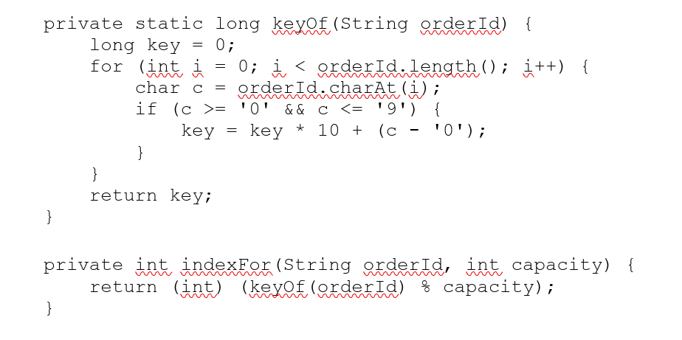
Order IDs are created in sequence, so consecutive orders fall in consecutive buckets: QD-1001 to QD-1007 go to buckets 9 to 15, and QD-1008 wraps around to bucket 0. As long as the active Order IDs span fewer numbers than there are buckets, no two of them collide. Keys are still compared with equals, so two different texts with the same digits could never be confused; only their bucket would be shared.
Collision resolution
Two keys collide when they produce the same bucket index, for example QD-1001 and QD-1017 in a table of 16 buckets, which both give 9. QuickDine uses separate chaining: the nodes of one bucket form a singly linked chain, and a search compares keys only within that chain (Skiena, 2020). A new node is inserted at the head of its chain, which takes constant time.
Load-factor monitoring and rehashing
The load factor is the number of entries divided by the number of buckets. Before a new key is inserted, put checks whether one more entry would make the load factor exceed 0.75. If so, rehash creates an array with twice as many buckets and relinks every existing node into the bucket given by its key modulo the new capacity. The nodes themselves are reused, so rehashing allocates only the new bucket array. Figure 5 shows the first rehash: the thirteenth key, QD-1013, would raise the load factor of 16 buckets above 0.75, so the table grows to 32 buckets before the key is stored.
Figure 5
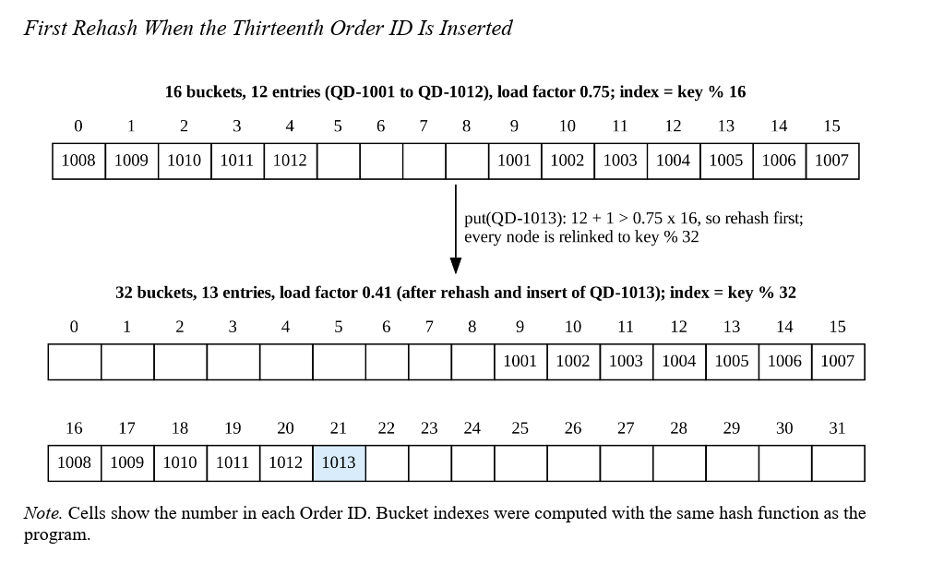

The pseudocode below gives the hash function, insertion with rehashing, search, and deletion as they are implemented in the HashTable class.
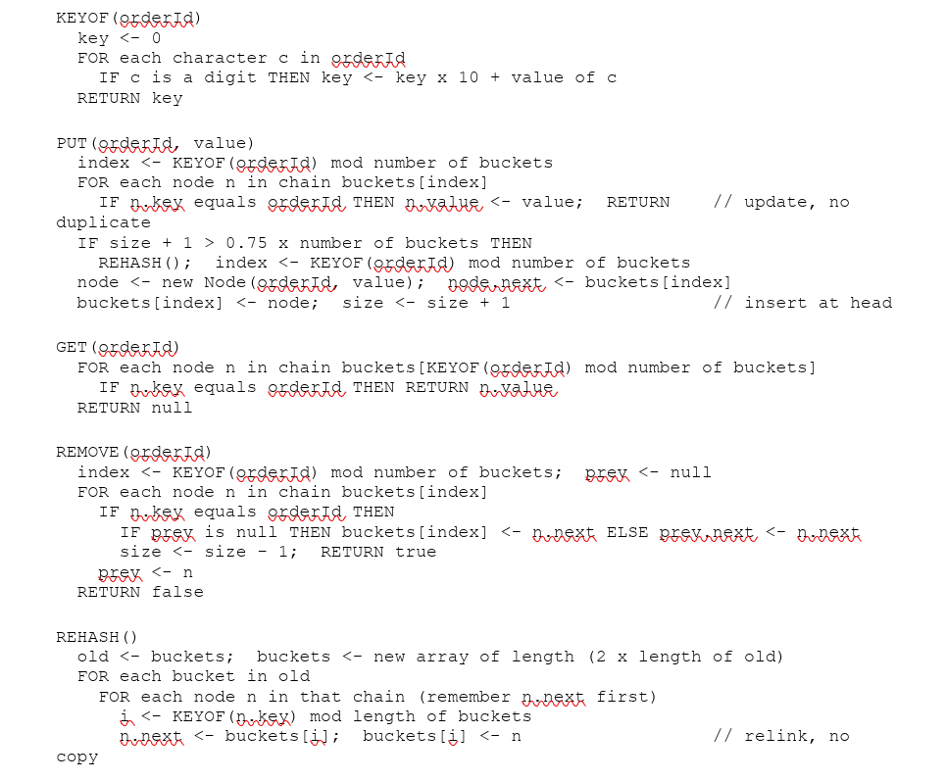
Figure 6 shows the same insertion as a flowchart, including the update of an existing key and the rehashing decision.
Measured behavior
Table 6 shows how the hash function spreads two patterns of Order IDs. The first pattern is the normal one: consecutive Order IDs starting at QD-1001. Because the table always has more buckets than entries and the keys are consecutive numbers, every key lands in its own bucket, so the longest chain has one entry even with 10,000 keys. The second pattern is the worst case for this hash function: Order IDs that differ by exactly 16, such as QD-1001, QD-1017, and QD-1033. They all share the same remainder modulo 16, so twelve of them form one chain of twelve, and even after rehashing they spread over only a few buckets because they also share remainders modulo 32 and 64.
Table 6
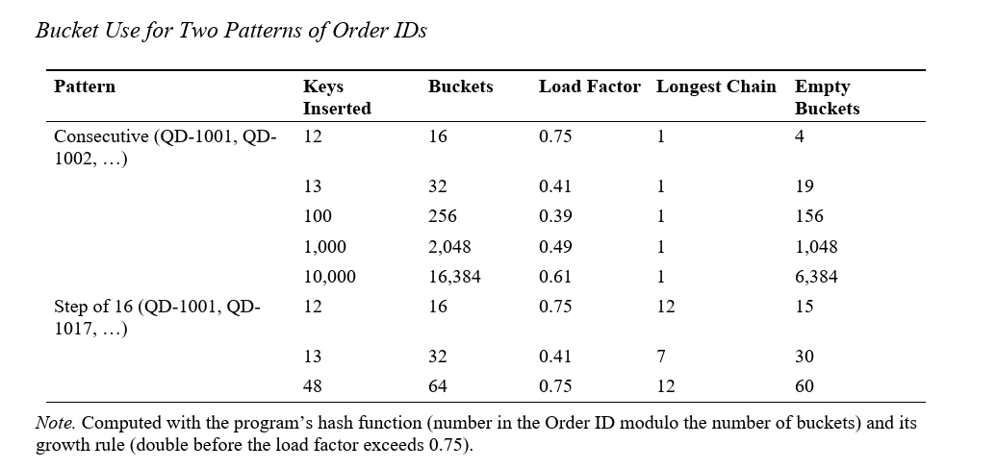
In the canteen, the worst pattern would require many orders to be placed and cleared while a few old orders stay active, which is unusual during one service period. Cormen et al. (2022) caution that the division method works poorly when the number of buckets is a power of 2 and the keys share low-order patterns, which is exactly what Table 6 shows; a prime number of buckets would spread such keys better. The group kept powers of 2 because doubling is simple to explain and the normal pattern of consecutive Order IDs never collides.
Reason for selection
Without an index, finding an order by its Order ID means checking the registry one order at a time, which takes O(n) time. A hash table with a load factor kept at or below 0.75 keeps chains short, so put, get, and remove take expected O(1) time (Cormen et al., 2022). Separate chaining was chosen because deletion is simple, which matters when finished orders are cleared, and because a full bucket never blocks an insertion.
Alternative considered
Open addressing stores every entry in the bucket array and probes for the next free slot. It saves the chain references, but deletions leave marker entries, called tombstones, that change the cost of later operations (Bender et al., 2021), so clearing finished orders would be harder to implement and explain. Java’s built-in HashMap was not used because the course requires a custom hash table. Linear search of the registry was kept only for functions that must visit every order anyway, which are described in the next section.
Time and space complexity. Table 7 gives the complexity, where n is the number of entries, m is the number of buckets, and L is the length of the Order ID, which is at most 12.
Table 7
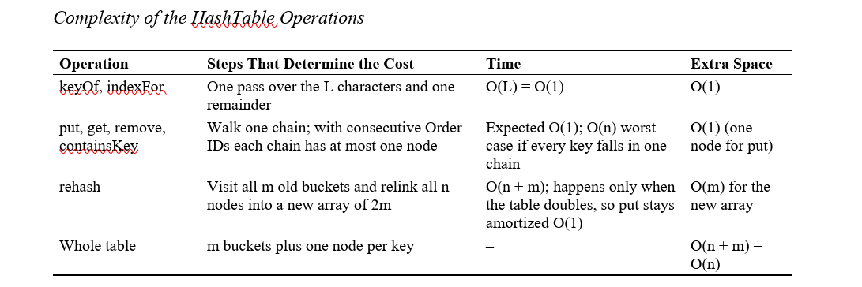
Strengths and limitations
The table gives near-constant lookups regardless of the number of orders, handles collisions without losing entries, and grows on its own. Its limitations are the worst-case pattern in Table 6, that the table never shrinks after orders are cleared, that it keeps no order among its keys and so cannot list orders by time or ID, and that its keys must be Order IDs, because the hash function reads only digits.
Connection to the Java classes and GUI
HashTable<V> contains a private static Node<V> class. OrderService holds one HashTable<Order> named index: placeOrder calls put; findOrder, findOrderOfUser, markReady, markClaimed, and cancelOrder call get; and clearFinishedOrders calls remove. In the windows, it serves the Track button of the Track Order tab, the selection of a row in My Orders, the Find Order ID button, and the Mark Ready, Mark Claimed, and Cancel Order buttons of the Staff Panel.
Tests used to verify correctness
HT-01 and HT-02 check put and get for a stored and a missing key; HT-03 checks that putting an existing key updates its value without a duplicate; HT-04 checks two keys in the same bucket; HT-05 checks removal from a chain; HT-06 checks that the thirteenth key triggers a rehash from 16 to 32 buckets; and HT-07 checks that 100 keys are all found after several rehashes. Through the service, SV-06, SV-07, SV-10, SV-13, SV-15, and SV-16 check status changes, clearing, ownership, an unknown Order ID, and a malformed Order ID.
Supporting Algorithms
Linear Search of the Registry
Some functions must look at every active order, so they use a linear search of the registry instead of the hash table. The method getOrdersOfUser collects a customer’s orders for My Orders, countUnclaimed counts the customer’s unclaimed orders before a new one is accepted under the three-order limit, and countByStatus fills the status counters. Each loop visits the n active orders once, so it takes O(n) time and O(1) extra space, plus O(k) for the k orders returned by getOrdersOfUser. The hash table cannot replace these loops because its key is the Order ID, not the customer ID or the status. The cost is acceptable because the registry holds only orders that have not been cleared. The pseudocode below shows the count used for the three-order limit.
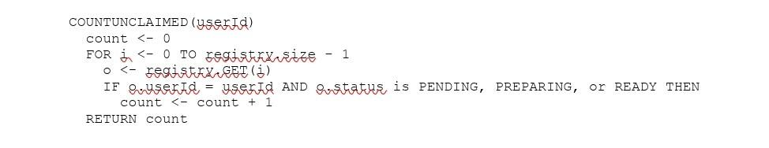

Order Status Rules
An order may change status only along the paths in Table 8. Each staff action first finds the order through the hash table and refuses the change if the order is not in the required status, so a step can never be skipped. Each check is O(1) after the expected O(1) lookup.
Table 8
Allowed Status Changes and the Structures Affected

From | Action | To | Structure Change
(new) | Place Order | Pending | registry.add, queue.enqueue, index.put
Pending | Serve Next Order (front order only) | Preparing | queue.dequeue
Pending | Cancel Order | Cancelled | queue.remove
Preparing | Mark Ready | Ready for Pickup | index.get only
Ready for Pickup | Mark Claimed | Claimed | index.get only
Claimed or Cancelled | Clear Finished | (removed) | registry.removeAt, index.remove

Input Validation
InputValidator checks each value with a loop over its characters. A Student or Teacher ID must contain only digits and have 6 to 12 of them; a staff username must contain 3 to 20 letters, digits, or underscores; a password must have 8 to 30 characters without spaces; and an Order ID must start with QD- followed by at least four digits, with at most 12 characters in total. The quantity limit of 1 to 20 is checked in the constructor of the OrderItem record, so no cart item can ever hold an invalid quantity (Bierman, 2021). Each check visits the L characters once, so it takes O(L) time with L at most 30, which is effectively constant. The same character tests are used by the windows while the user types, and the full checks are repeated by the services before any structure changes.
Salted Password Hashing and Log-In
The log-in is not one of the course data structures, but it controls who may use each window. LoginService creates a 16-byte salt with SecureRandom for each new account, computes the SHA-256 digest of the salt followed by the password with Java’s MessageDigest class (Oracle, 2021e), and stores both values as hexadecimal text. SHA-256 is a one-way hash function, so the password cannot practically be computed back from the stored digest (Paar et al., 2024). AccountDatabase sends every SQL command that contains user input through a PreparedStatement with question-mark placeholders (Oracle, 2021d), and the table lives in an SQLite file that needs no server (Gaffney et al., 2022). The pseudocode below shows the log-in, including the creation of a customer account at the first log-in.

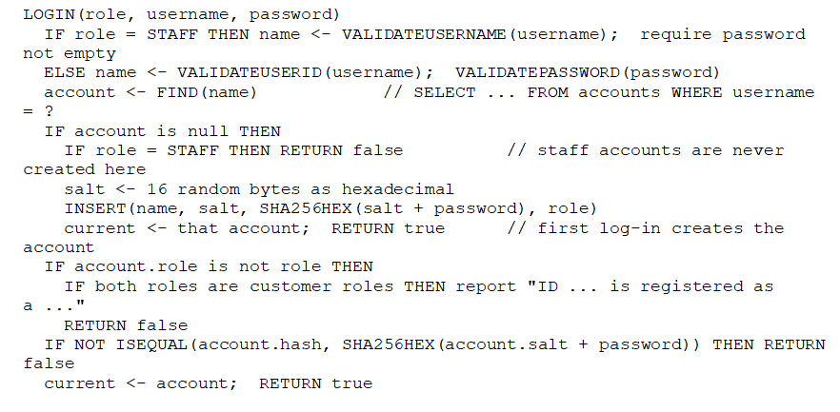

Hashing a password of at most 30 characters takes O(1) time, and FIND uses the primary key, so SQLite locates the row without reading every account. The separate salt for each account means that two customers with the same password have different stored hashes (test LG-10). The implementation is still weaker than current guidance: Temoshok et al. (2025) require a password-hashing scheme with a cost factor and a limit on failed attempts, neither of which QuickDine has. The automatic creation of customer accounts also means that the log-in proves only that the same person returns to the same ID, not that the ID belongs to a real student or teacher.
Integration of the Data Structures
The three structures must always agree about which orders exist. OrderService keeps three rules true after every operation: every order in the queue is also in the registry and the hash table; the registry and the hash table contain exactly the same orders; and the queue contains exactly the orders whose status is Pending. Only OrderService changes the structures, and each of its public methods validates its input before changing anything and then updates all the structures it affects before it returns, so the rules hold whenever the windows read the data. Table 9 shows which operation touches which structure.
Table 9
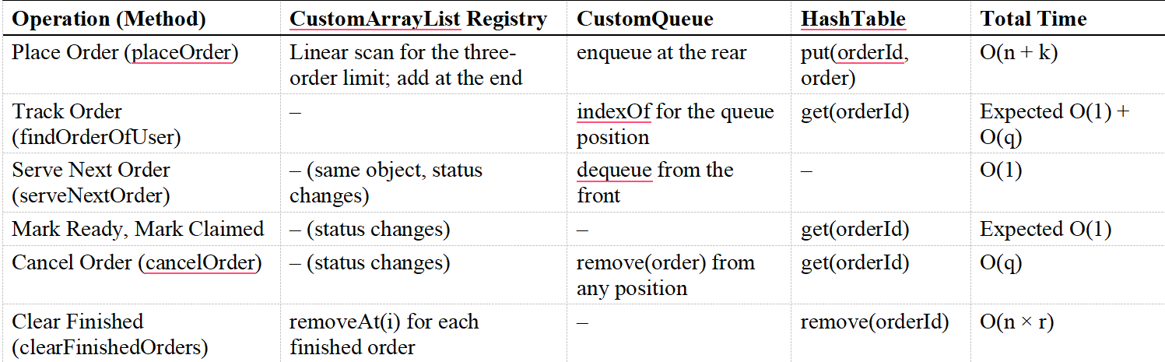
What Each Order Operation Does to Each Structure

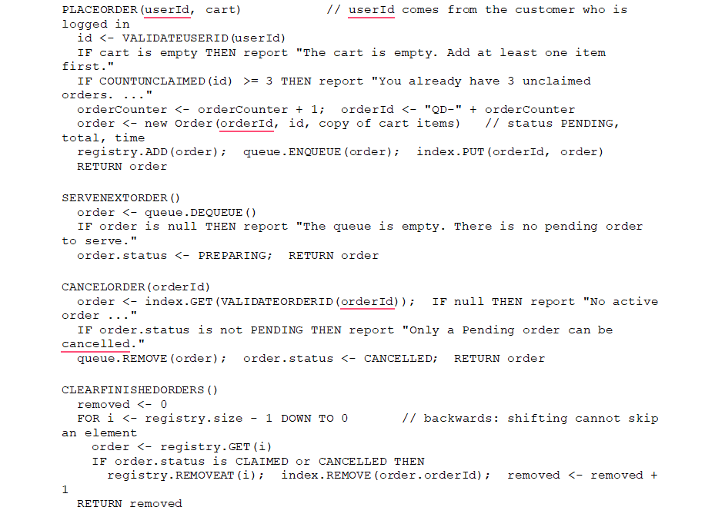
The pseudocode below shows the four OrderService operations that change more than one structure or remove orders.

CLEARFINISHEDORDERS walks the registry from the last index to the first. If it walked forward, removing the element at index i would shift the next element into index i, and the loop would skip it when i increased. Walking backwards avoids this because the elements that shift have already been checked. Each removal shifts up to n elements, so clearing r orders costs O(n × r) time, which is O(n²) in the worst case when every order is finished. This is acceptable for a canteen, where the list holds at most a few hundred orders, but it is the slowest operation in the application. The Order constructor copies the cart items into its own list, so clearing the cart after ordering does not change the order (test CT-04).
Errors in one operation do not stop the application. The services throw IllegalArgumentException for invalid input and IllegalStateException for an action that is not allowed in the current state, before changing any structure. The window catches the exception and shows its message, and the structures remain as they were.
Complexity Summary and Pilot Benchmark
Table 10 summarizes the expected cost of every action that the users trigger, combining the tables above.

Table 10
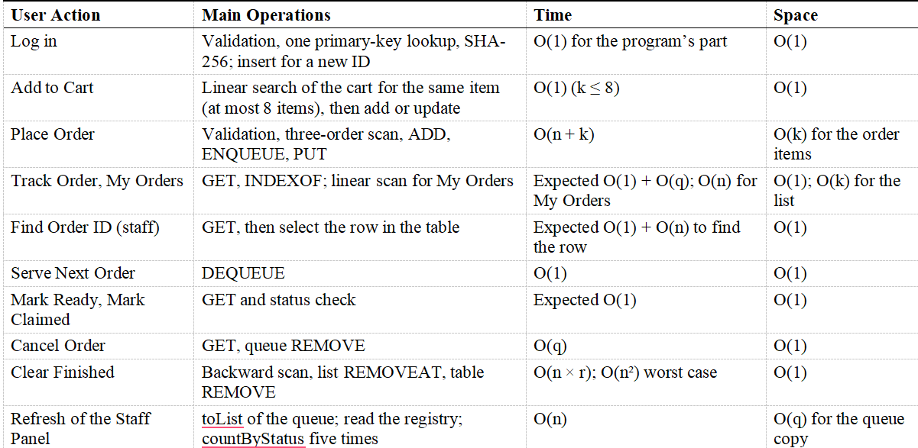
Summary of Time and Space Complexity

References:

Ardani, D., & Aji, A. S. (2024). Development of a Web-Based Food and Beverage Ordering System for university canteens using the LaRaVel Framework at University of Technology Yogyakarta. Journal of Scientific Research Education and Technology (JSRET), 3(4), 1462–1474. https://doi.org/10.58526/jsret.v3i4.521
Bari, P., Patil, Y., Sathawane, N., Suroshe, T., & Patil, A. (2025). Deploying an intelligent online food ordering system to optimize college canteen operations. International Conference on Futuristic Technology (INCOFT), 263–268. https://doi.org/10.5220/0013613700004664
Bhattarai, I. B., Bhandari, A., Pokhrel, N., Adhikari, A., & Baral, H. P. (2024). QR-based canteen Management system. Journal of Information Technology and Digital World, 6(3), 217–227. https://doi.org/10.36548/jitdw.2024.3.001
Dey, N., & Dey, T. (2024). An approach to Cashless Canteen Mobility Solution. An Approach to Cashless Canteen Mobility Solution, 14–19. https://doi.org/10.1109/ivit62102.2024.10692492
Kambli, A., Sinha, A. A., & Srinivas, S. (2020). Improving campus dining operations using capacity and queue management: A simulation-based case study. Journal of Hospitality and Tourism Management, 43, 62–70. https://doi.org/10.1016/j.jhtm.2020.02.008
Nwekori, F., & Ogbaga, I. (2025). Design and implementation of a Web-Based food Ordering platform for academic environments. Journal of Digital Food Energy & Water Systems, 6(2). https://doi.org/10.36615/918nh382
Rahman, D. S. A., & Othman, M. (2024, December 9). Food ordering system in the school canteen for teachers. https://publisher.uthm.edu.my/periodicals/index.php/aitcs/article/view/16382
Surbakti, E. E., Rizky, N., Pane, I. Z., & Khouwira, F. (2024). Efficient Order Management: Design and Implementation of a System using Scheduling Algorithms and Expert Validation. Ultimatics Jurnal Teknik Informatika, 15(2), 115–121. https://doi.org/10.31937/ti.v15i2.3489
Usluer, F. O. (2025). Solving Queue Problems in a Campus Dining Service with Discrete Event Simulation. Ege Akademik Bakis (Ege Academic Review), 25(2), 351–360. https://doi.org/10.21121/eab.20250207
Yinuo. (2026, January 29). GOAL OF THE MONTH – Goal 8: Decent work and Economic growth - United Nations Sustainable Development. United Nations Sustainable Development. https://www.un.org/sustainabledevelopment/goal-of-the-month-goal-8-decent-work-and-economic-growth/

RUBRIC A: MIDTERM PROJECT OUTPUT (Application, Paper, Hard Copy,and Soft Copy)
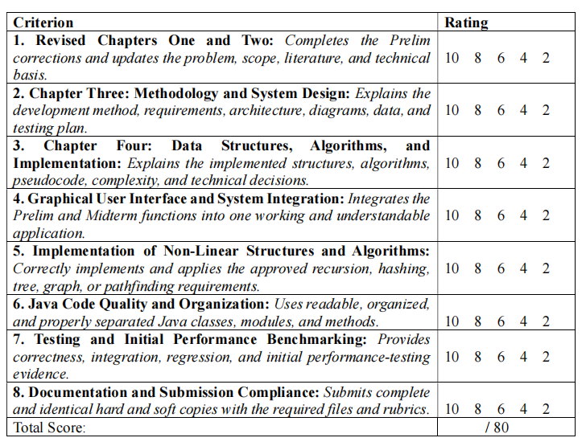

RUBRIC B: GROUP DEFENSE AND PRESENTATION
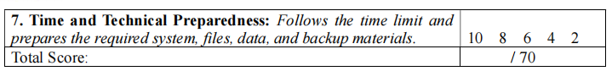
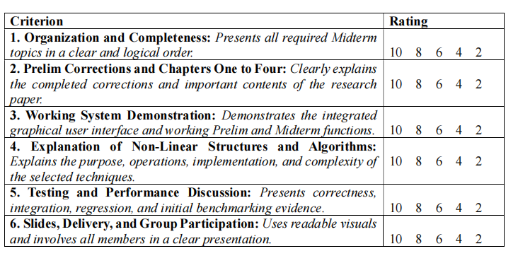

RUBRIC C: INDIVIDUAL QUESTION-AND-ANSWER PERFORMANCE
